LAB MANUAL

Name: Karan M
Register Name: 192412062
Course Code: ITA 0603
Course Name: Machine Learning

EXPERIMENT 1 – FIND-S ALGORITHM
Aim
To implement and demonstrate the FIND-S algorithm for finding the most specific hypothesis based on a given set of training data samples.
Procedure
- Define the training dataset.
- Initialize the hypothesis with the most specific values.
- Consider only positive training examples.
- Compare positive examples with the hypothesis.
- Replace differing attributes with '?'.
- Ignore negative examples.
- Display the final hypothesis.
Code and Output
- Dataset 1
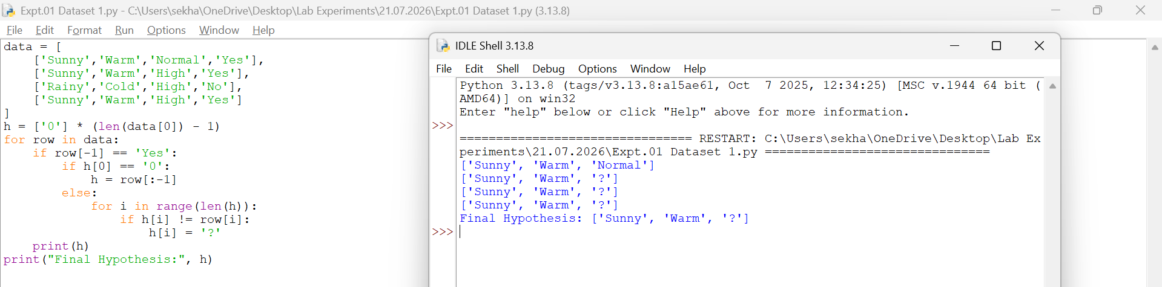
- Dataset 2
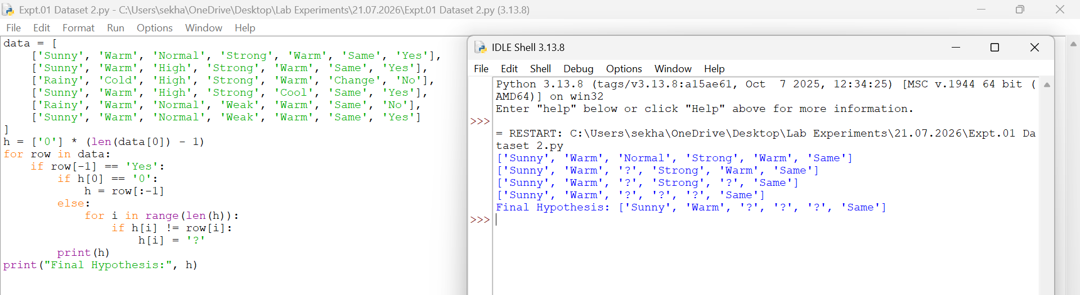
- Dataset 3
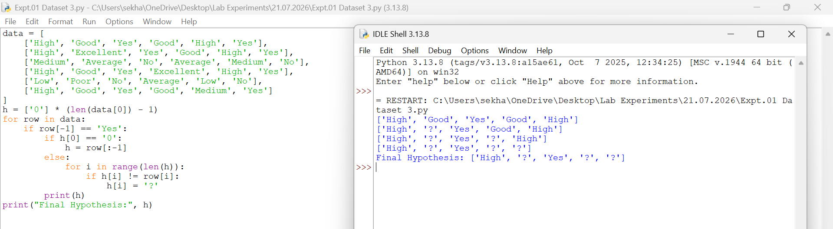
- Dataset 4
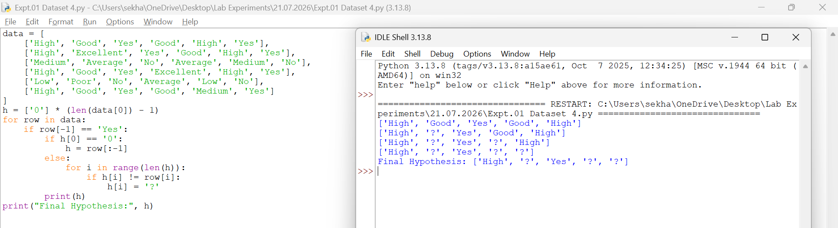
- Dataset 5
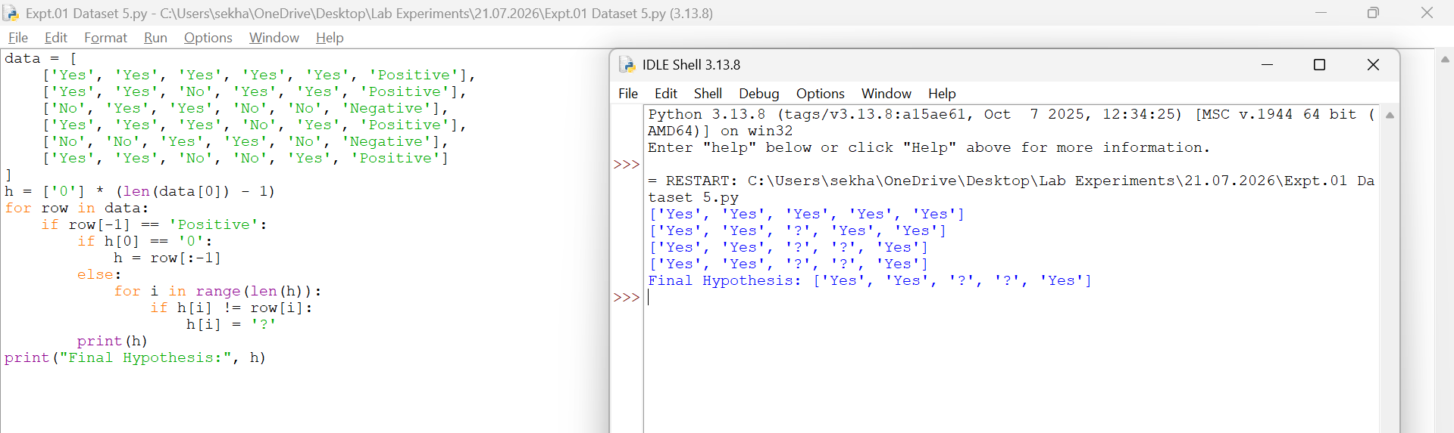
- Dataset 6
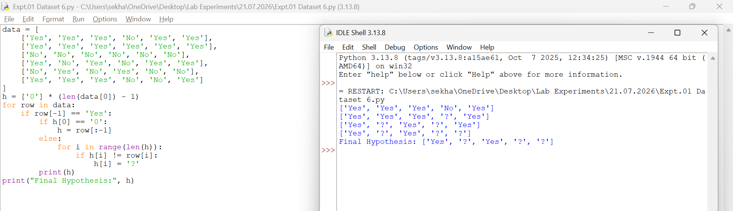
Result
Thus, the FIND-S algorithm was implemented successfully and the most specific hypothesis was obtained.
EXPERIMENT 2 – CANDIDATE ELIMINATION ALGORITHM
Aim
To implement and demonstrate the Candidate Elimination algorithm and obtain all hypotheses consistent with the training examples.
Procedure
- Define the training dataset.
- Initialize the Specific hypothesis (S).
- Initialize the General hypothesis (G).
- For positive examples, generalize S.
- For negative examples, specialize G.
- Update S and G after each iteration.
- Display the final hypotheses.
Code and Output
- Dataset 1
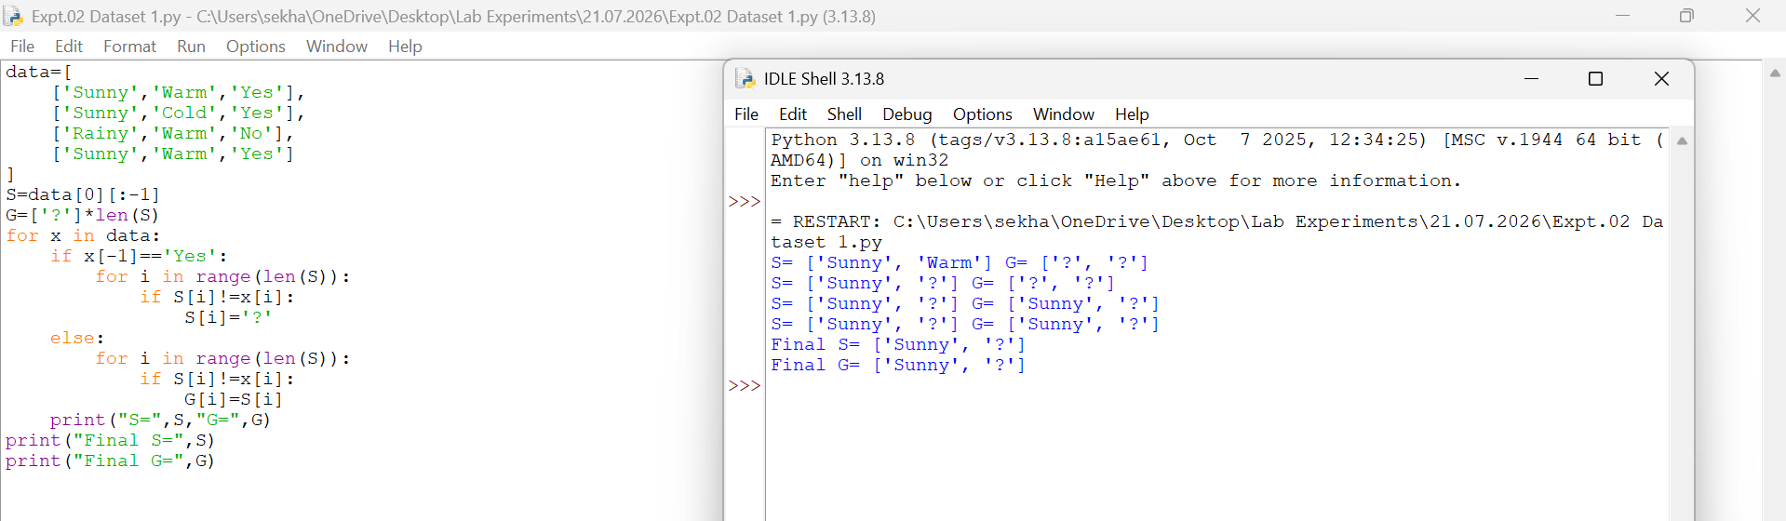
- Dataset 2
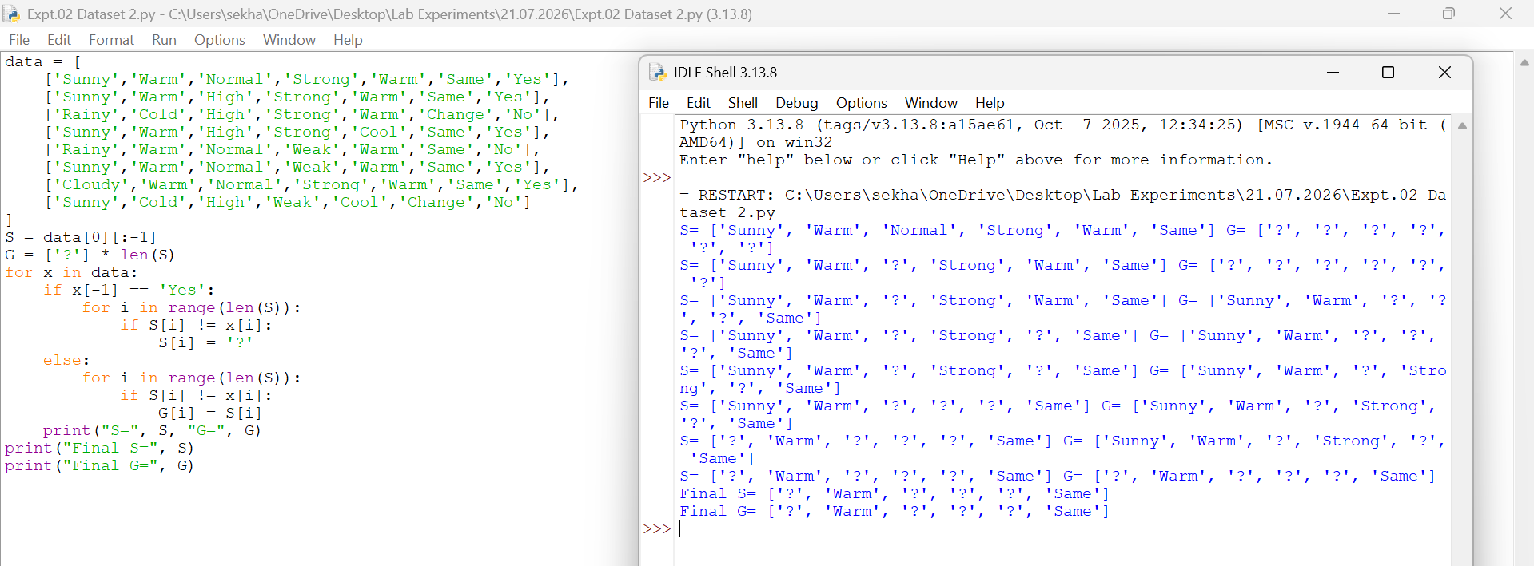
- Dataset 3
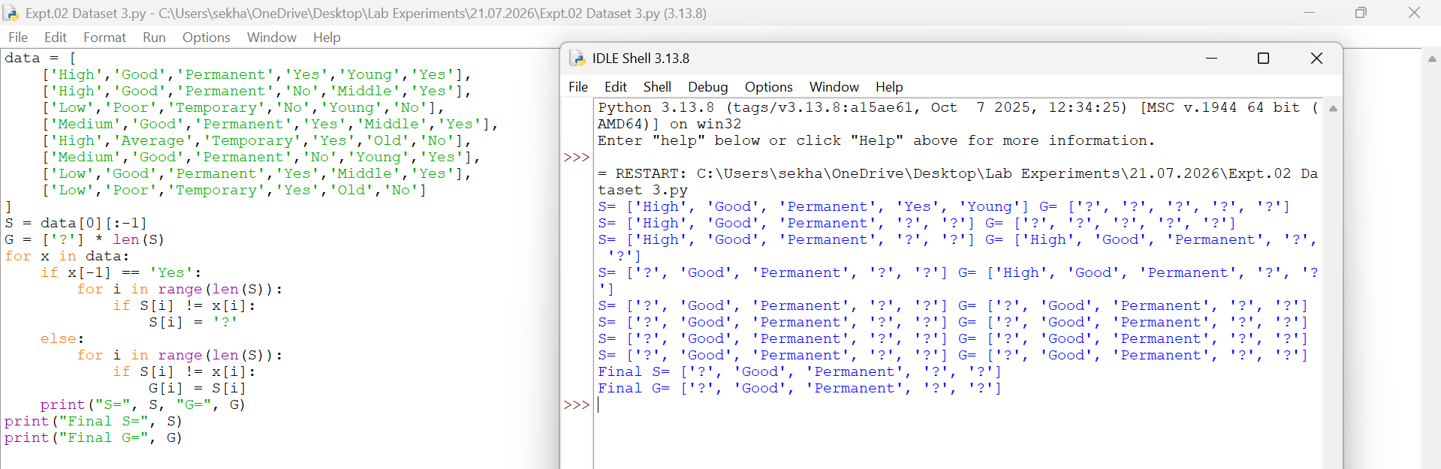
- Dataset 4
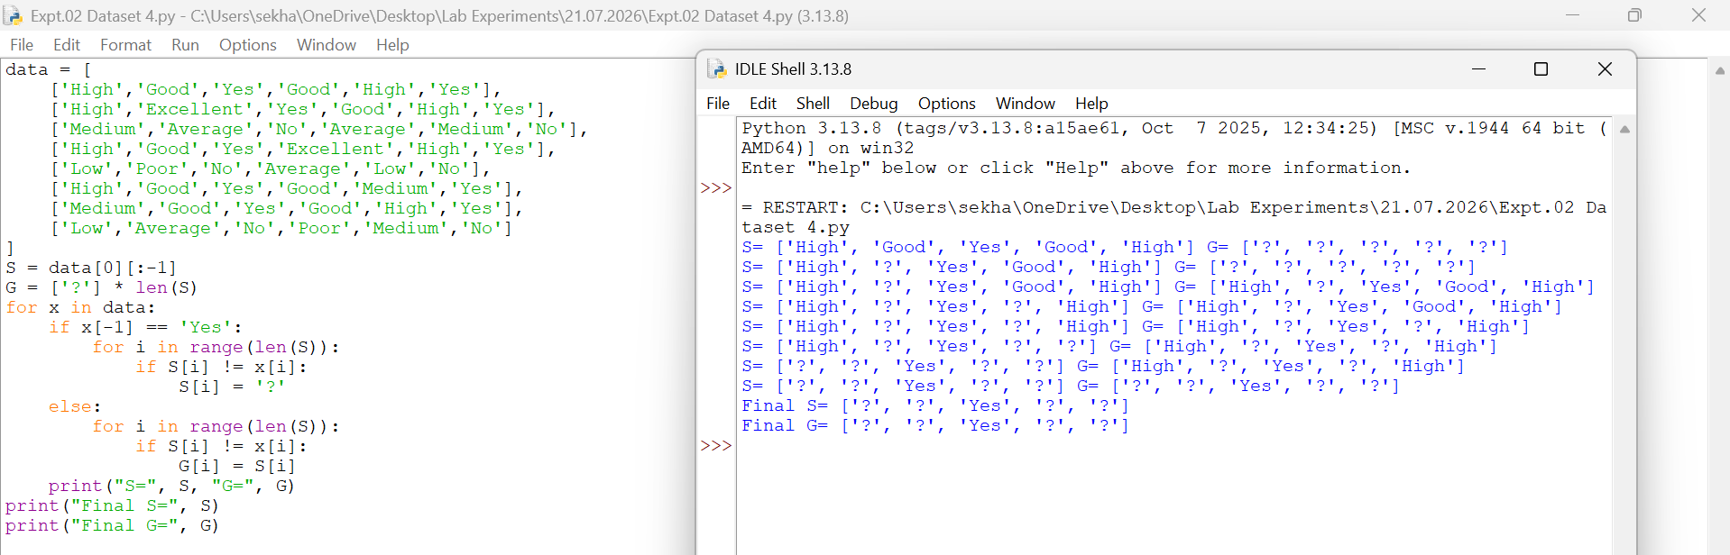
- Dataset 5
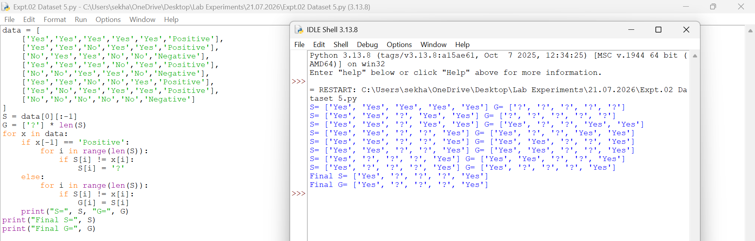
- Dataset 6
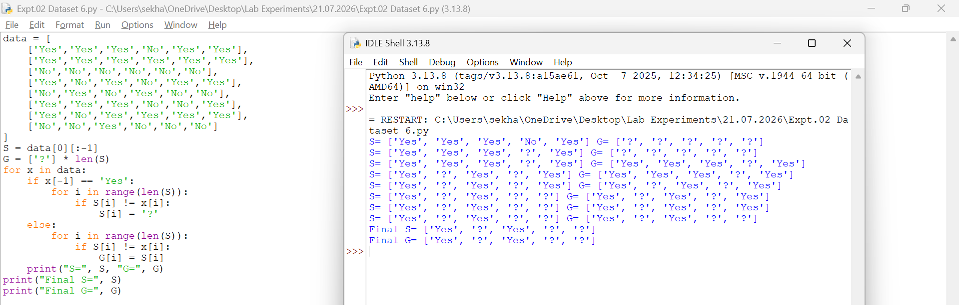
Result
Thus, the Candidate Elimination algorithm was implemented successfully and the final Specific and General hypotheses were obtained.
EXPERIMENT 3 – DECISION TREE (ID3) ALGORITHM
Aim
To implement and demonstrate the working of the Decision Tree based ID3 algorithm and classify a new sample.
Procedure
- Import the Decision Tree Classifier.
- Create the training dataset and target values.
- Create the Decision Tree model using entropy.
- Train the model using the training data.
- Classify a new sample using the trained model.
- Display the predicted result.
Code and Output
- Dataset 1
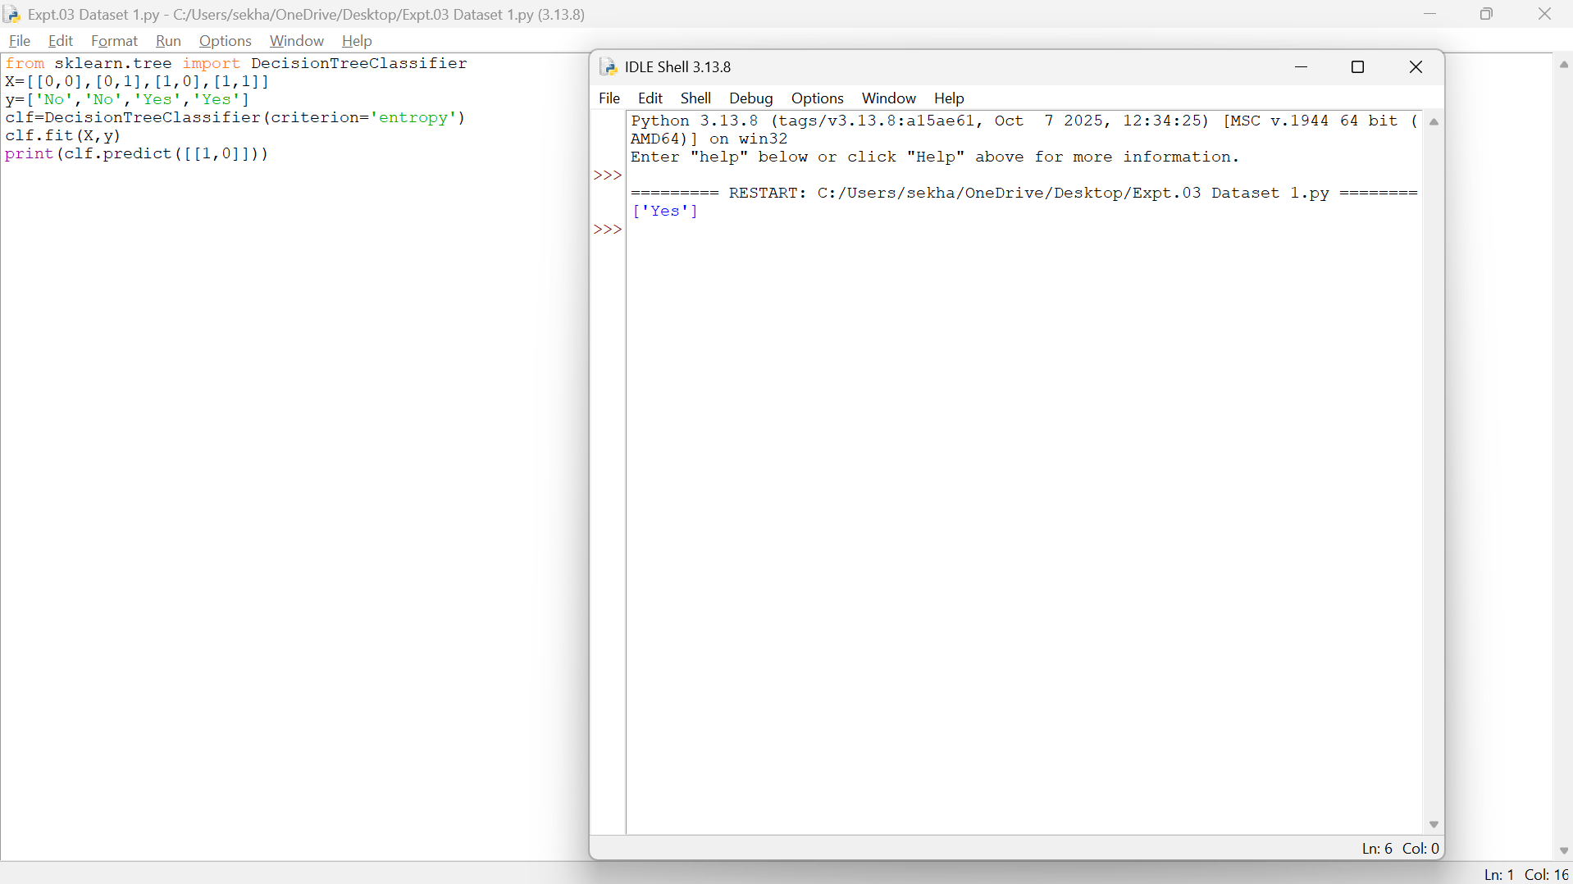
- Dataset 2
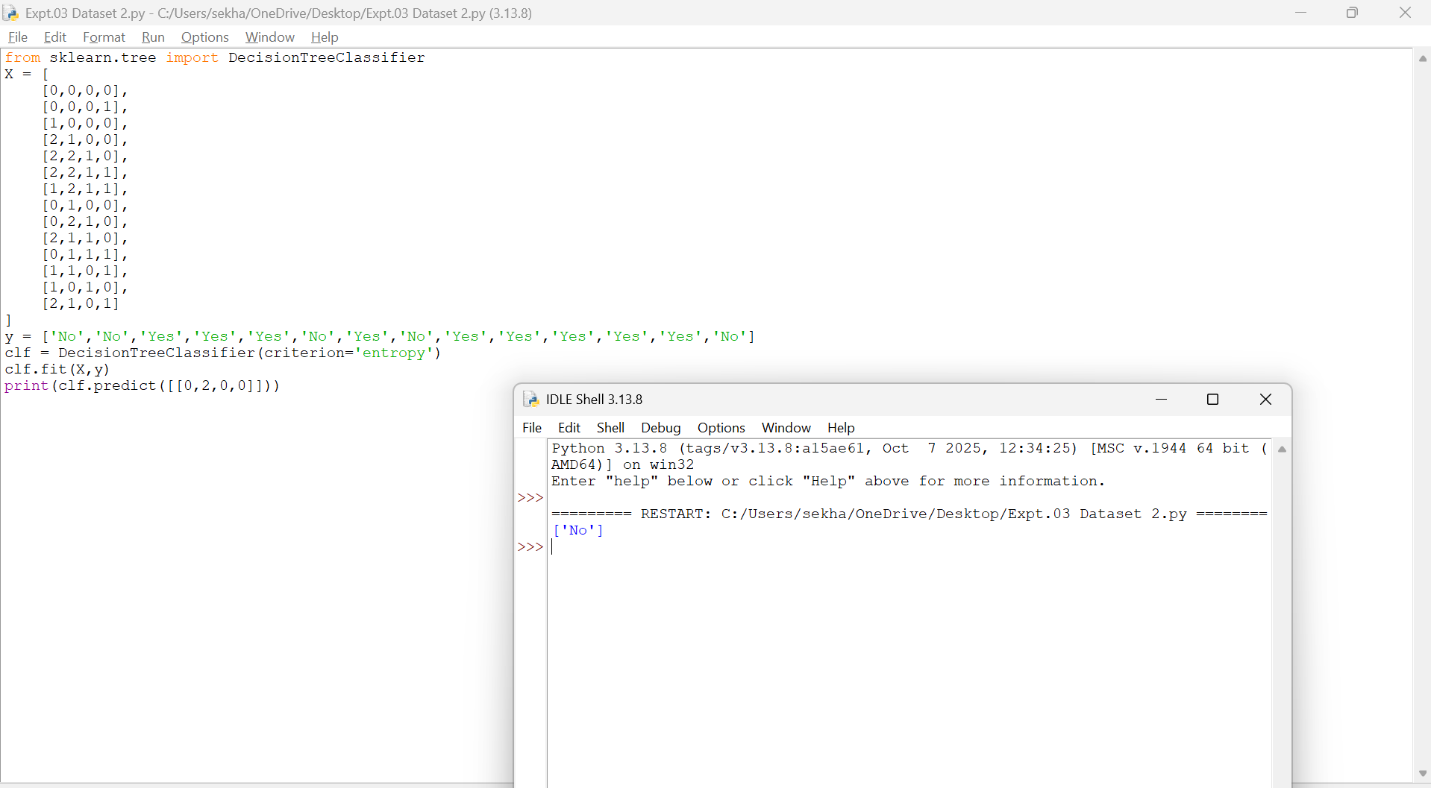
- Dataset 3

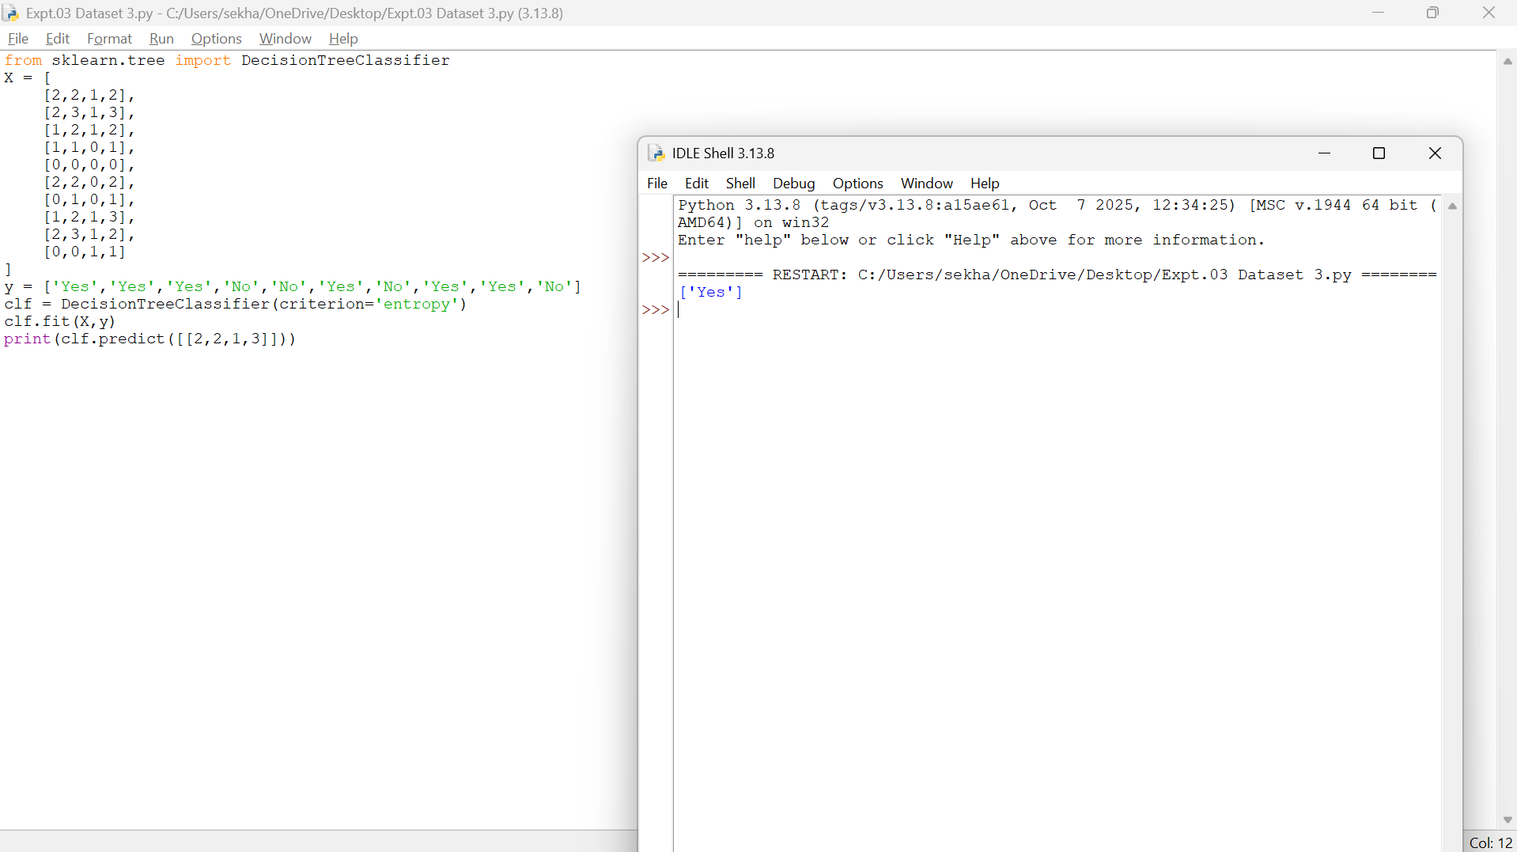
- Dataset 4
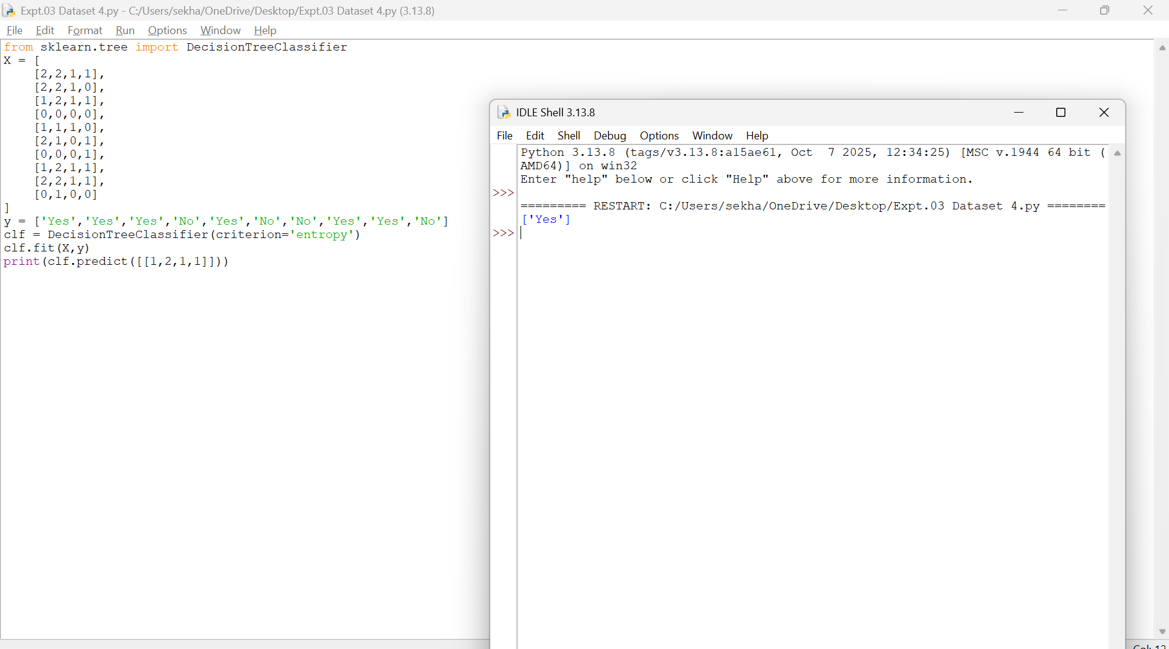
- Dataset 5
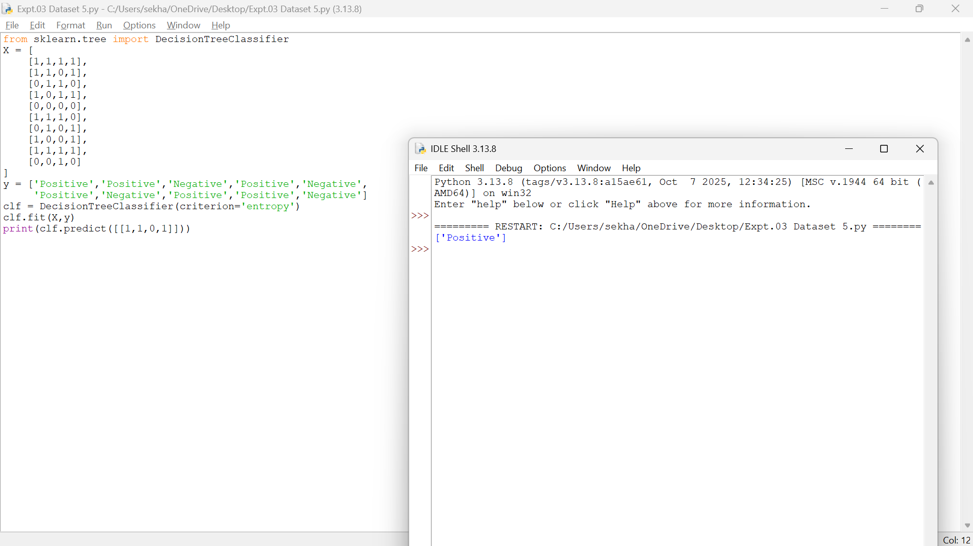
- Dataset 6
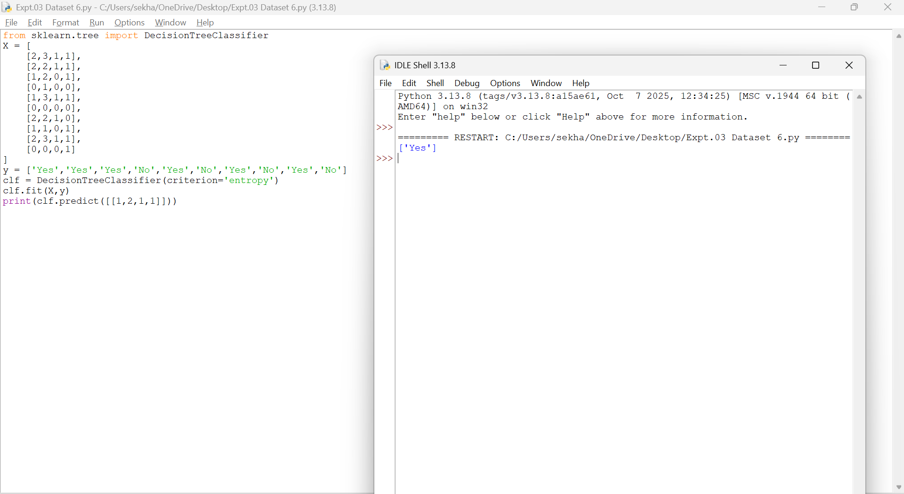
Result
Thus, the Decision Tree based ID3 algorithm was implemented successfully and the new sample was classified as 'Yes'.
EXPERIMENT 4 – ARTIFICIAL NEURAL NETWORK USING BACKPROPAGATION
Aim
To build an Artificial Neural Network using the Backpropagation algorithm and classify a new sample.
Procedure
- Import the MLPClassifier.
- Create the training dataset and target values.
- Create the ANN model.
- Train the model using Backpropagation.
- Test the model using a new sample.
- Display the predicted result.
Code and Output
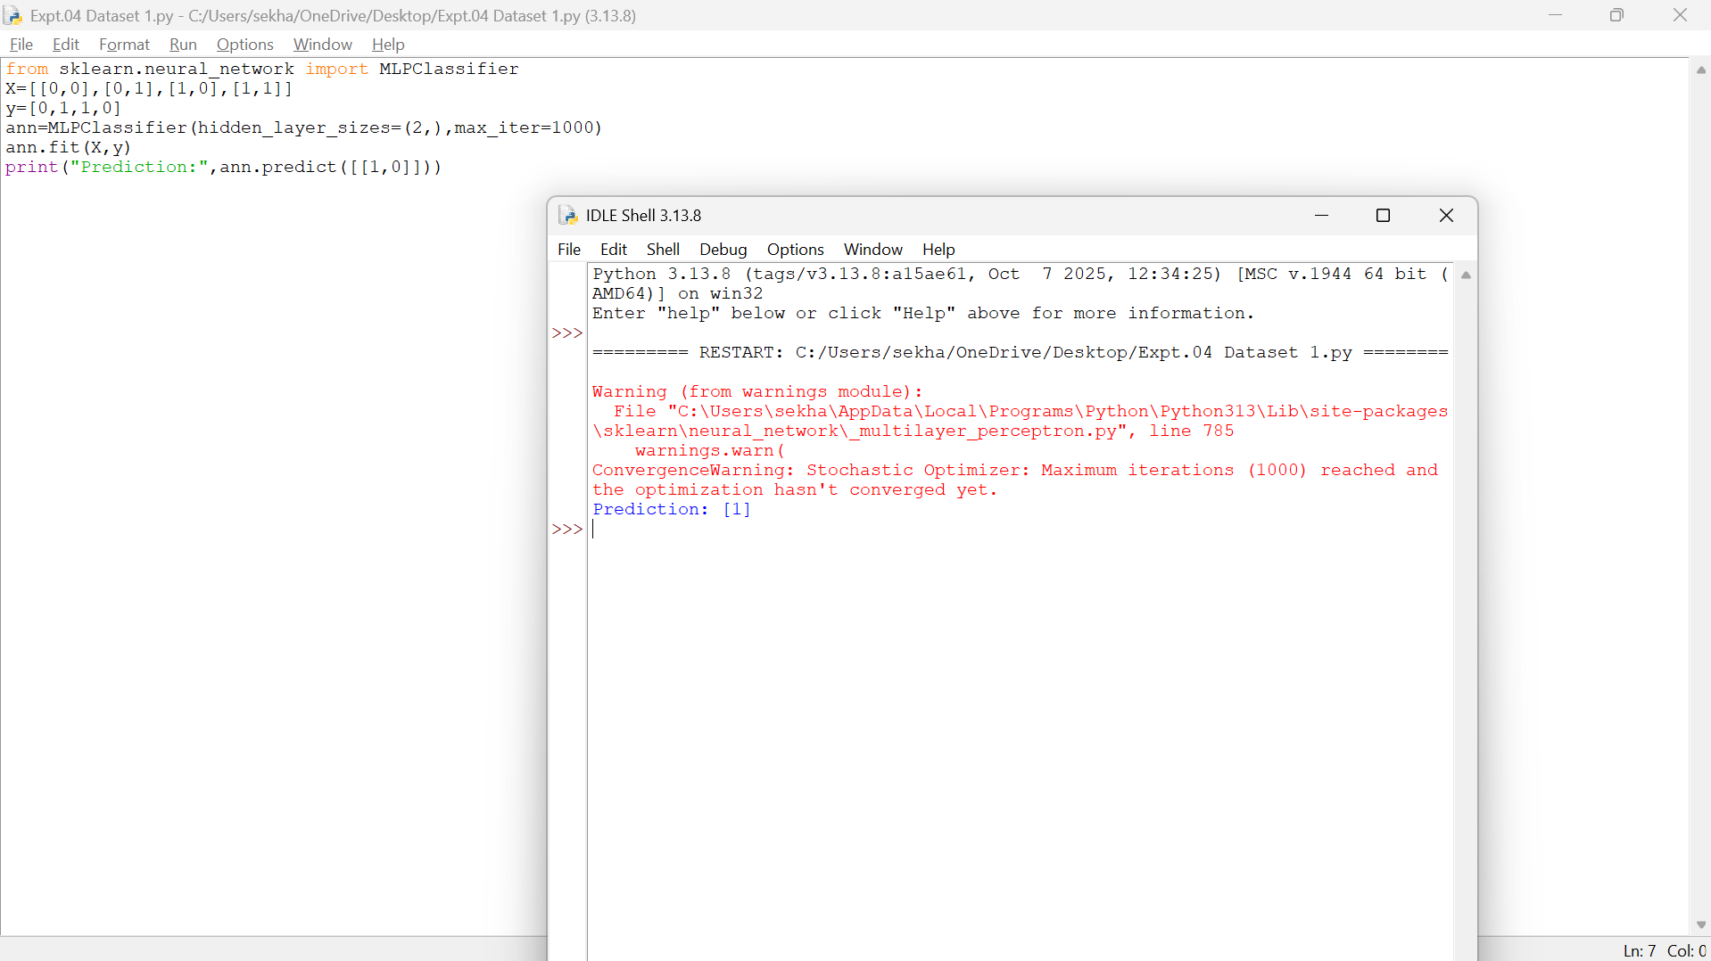
- Dataset 1
- Dataset 2
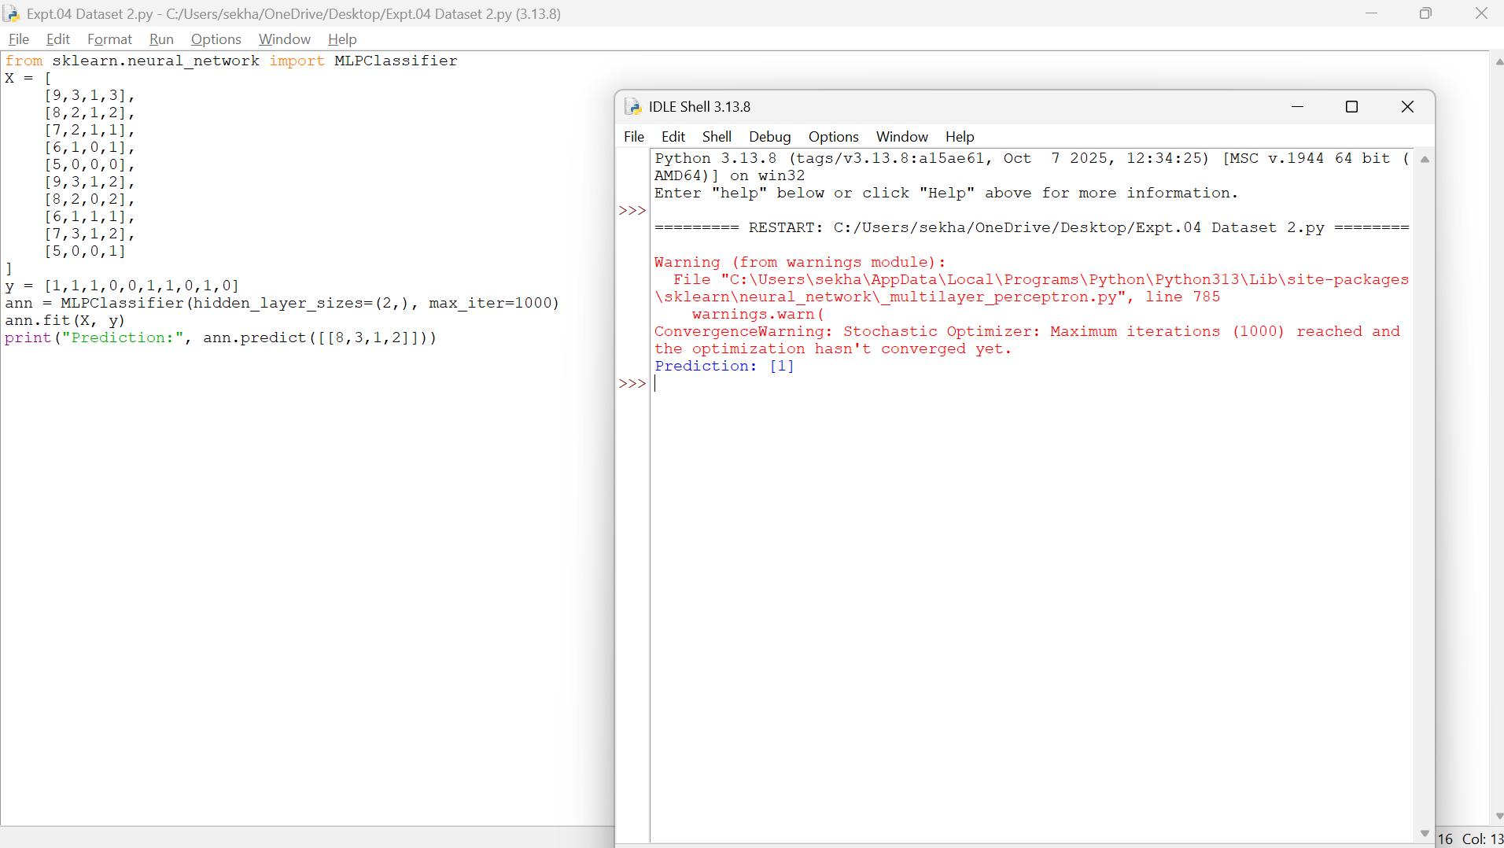
- Dataset 3
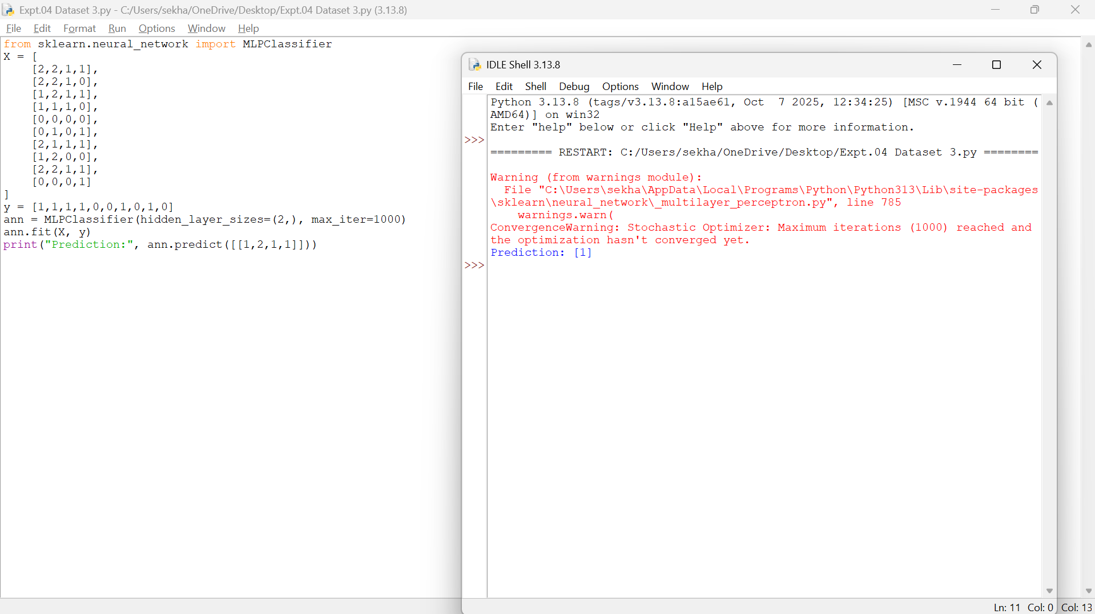
- Dataset 4
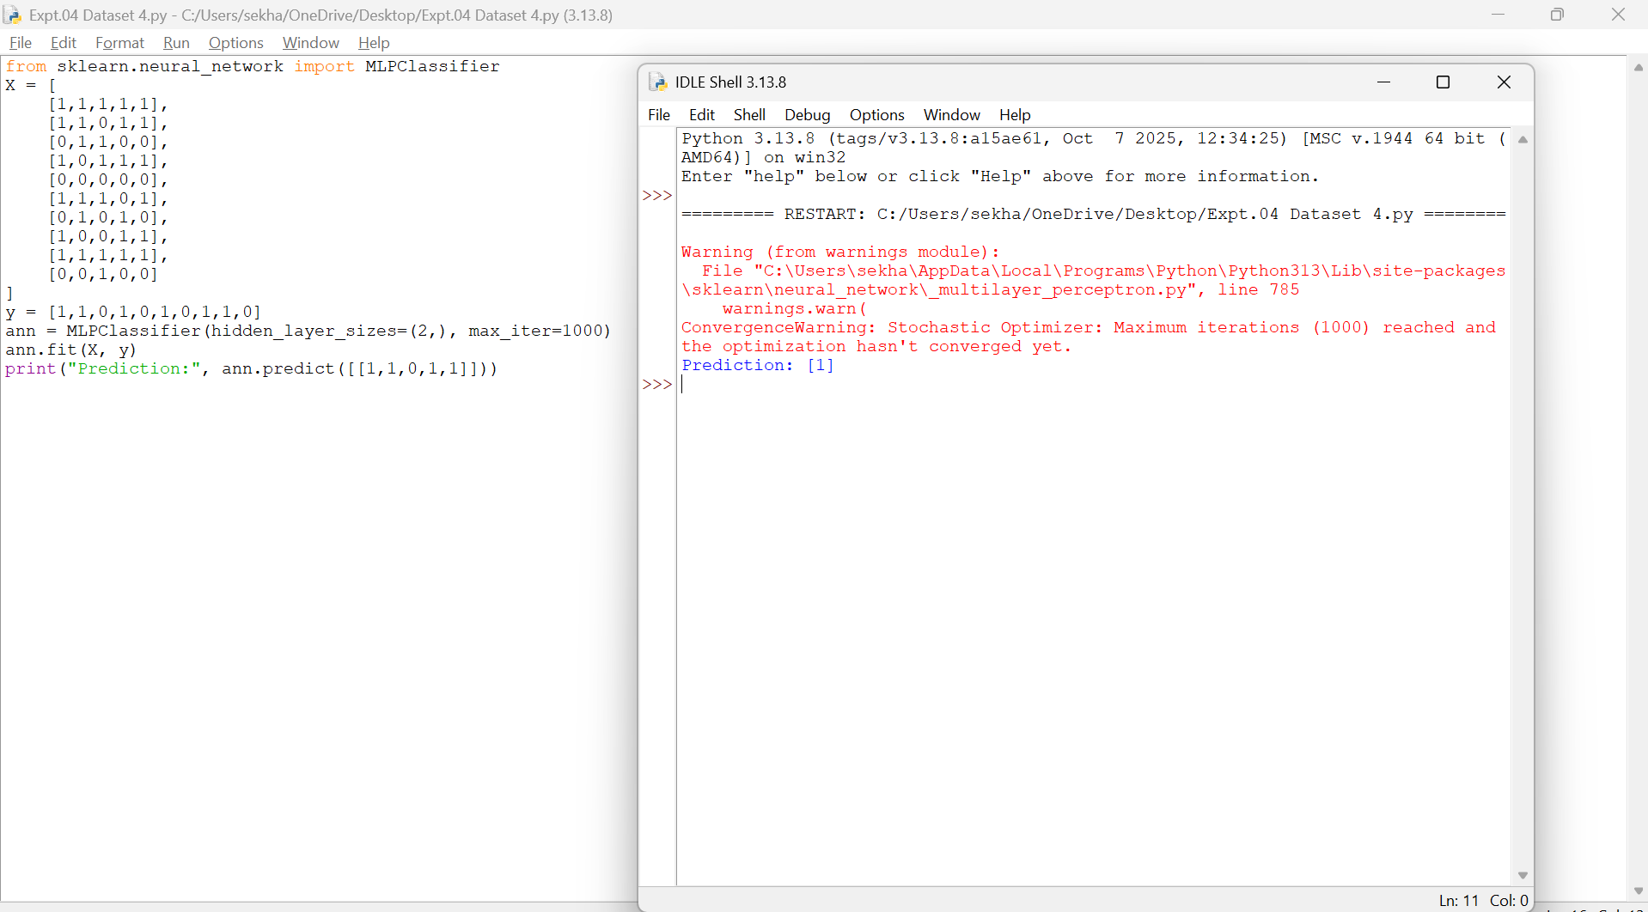
- Dataset 5
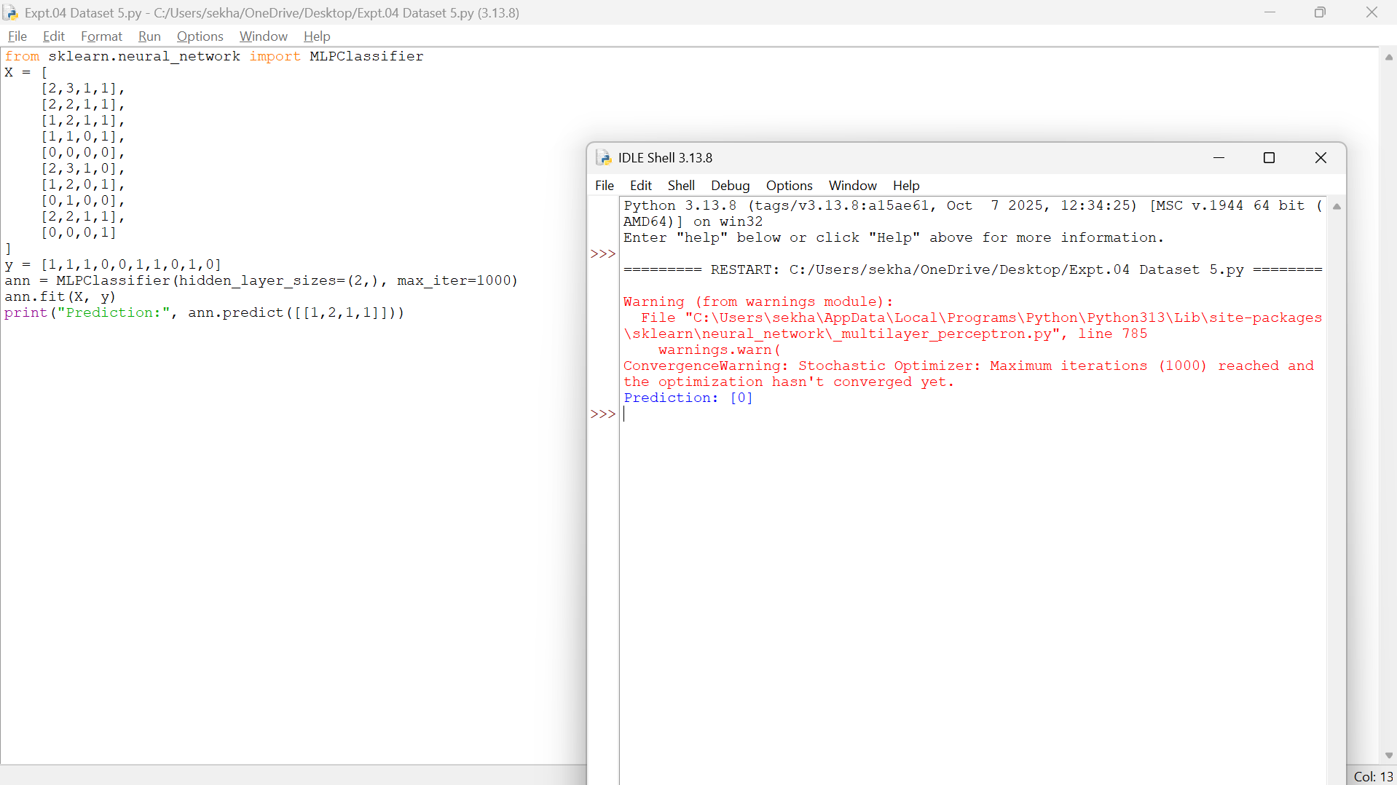
- Dataset 6
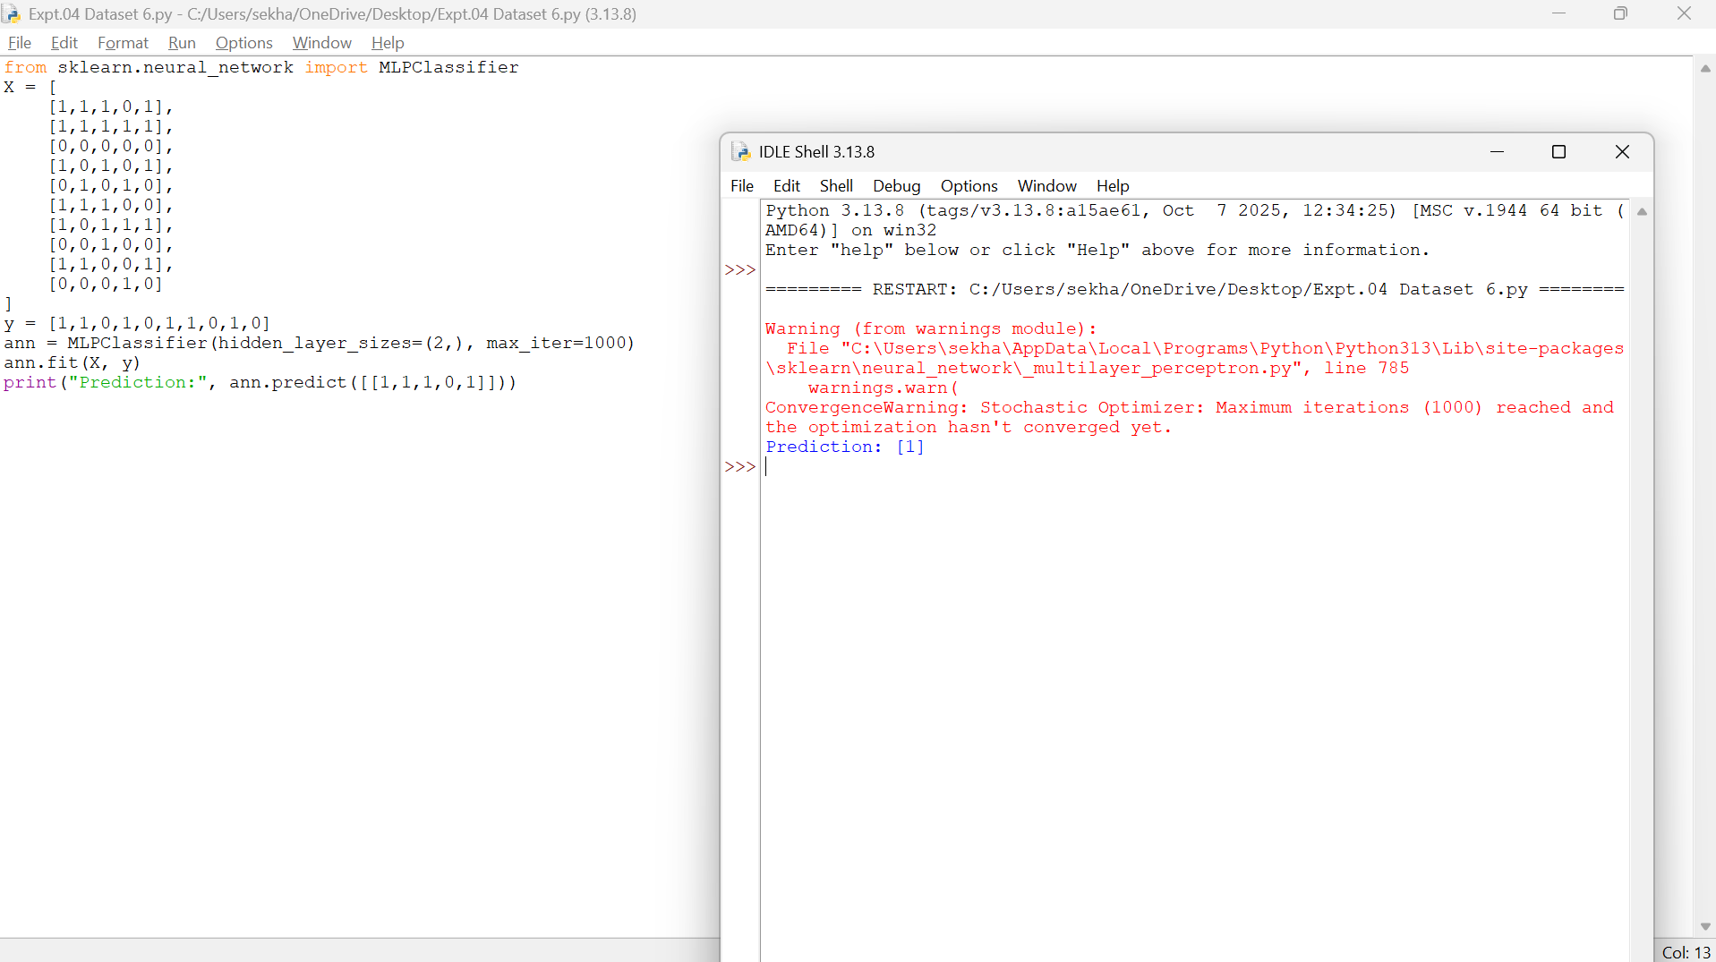Result
Thus, the Artificial Neural Network using the Backpropagation algorithm was implemented successfully and the test sample was classified correctly.
EXPERIMENT 5 – K-NEAREST NEIGHBOURS (K-NN)
Aim
To implement the K-Nearest Neighbours (K-NN) algorithm in Python and classify a new sample.
Procedure
- Import the KNeighborsClassifier.
- Create the training dataset and class labels.
- Create the K-NN model with K = 3.
- Train the model using the training data.
- Predict the class of a new sample.
- Display the predicted result.
Code and Output
- Dataset 1
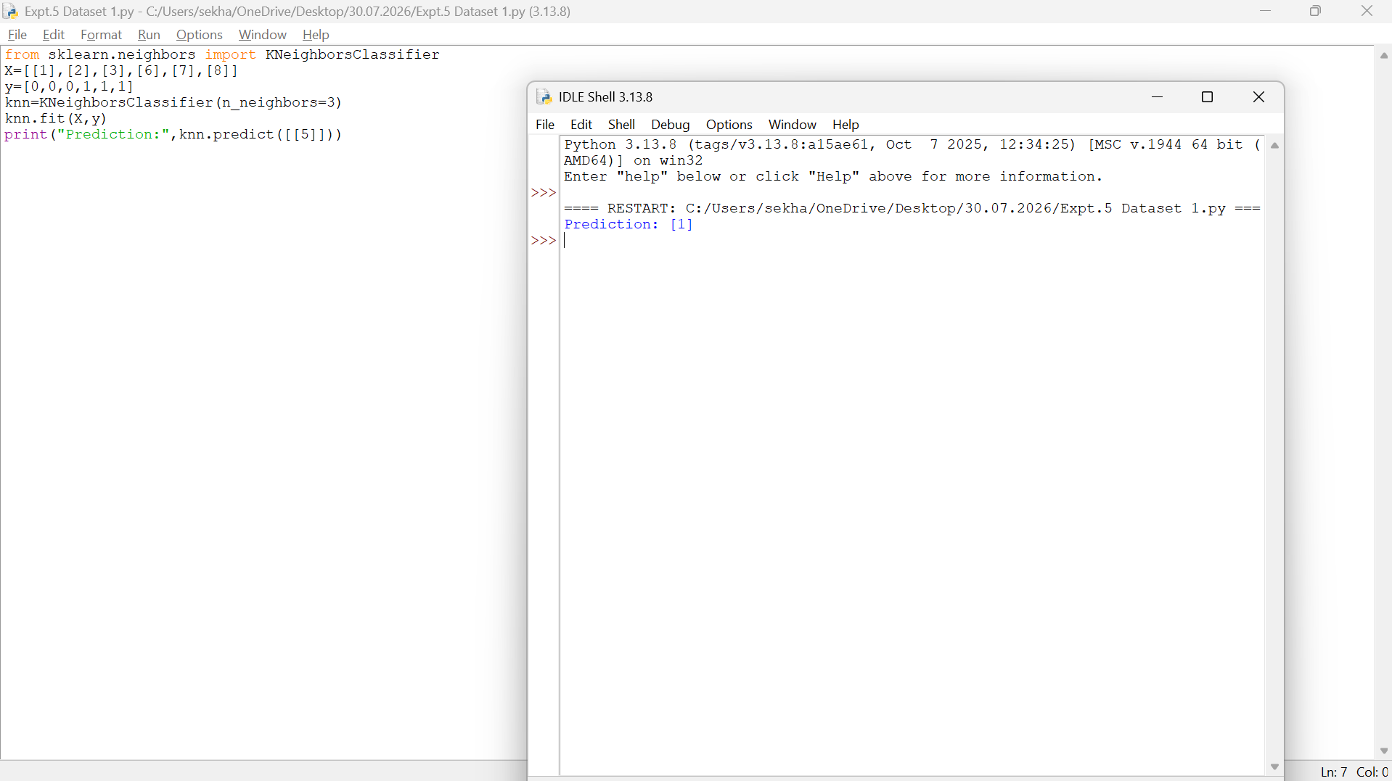
- Dataset 2
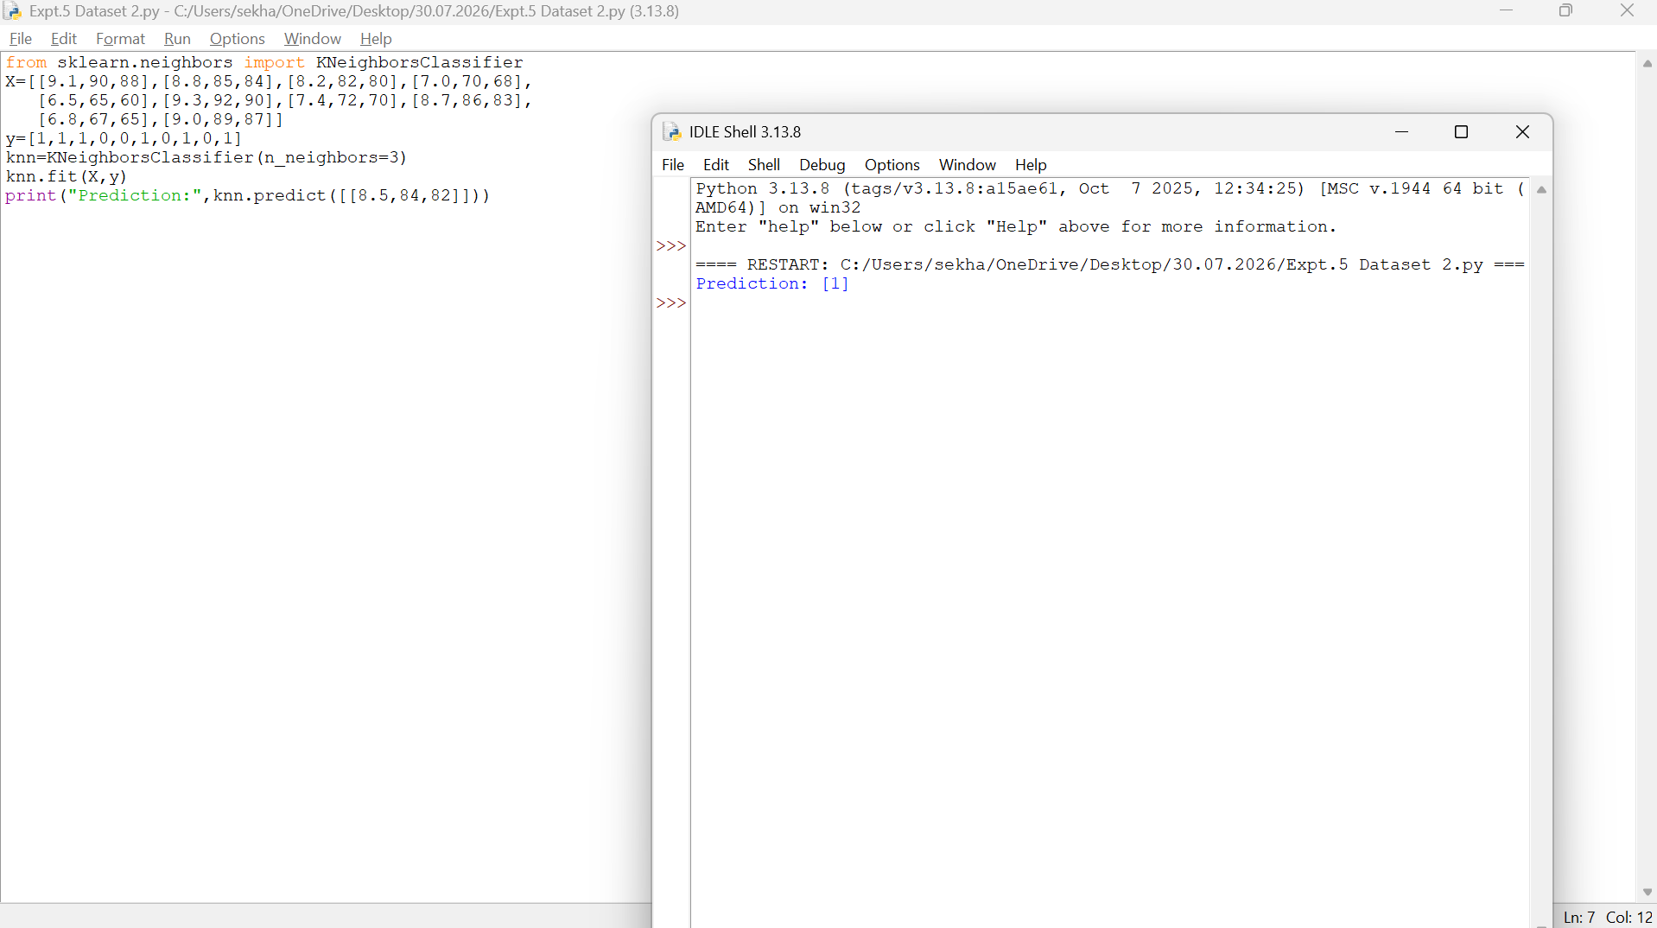
- Dataset 3
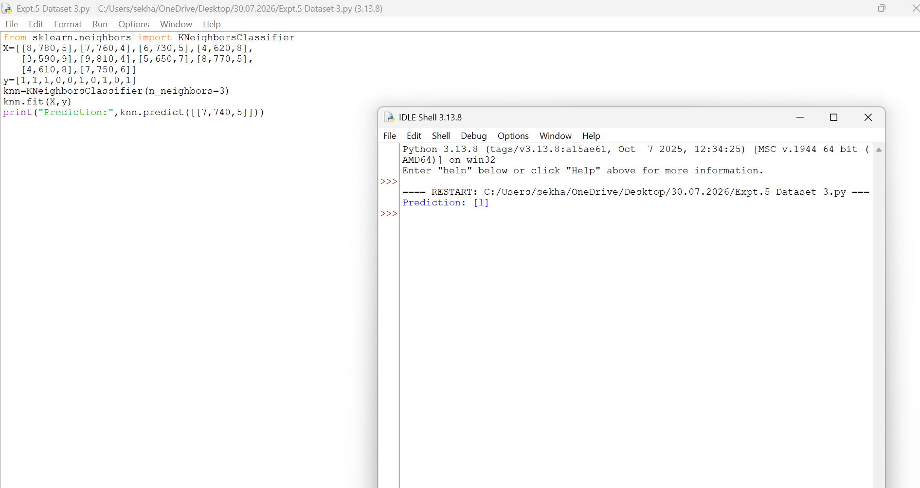
- Dataset 4
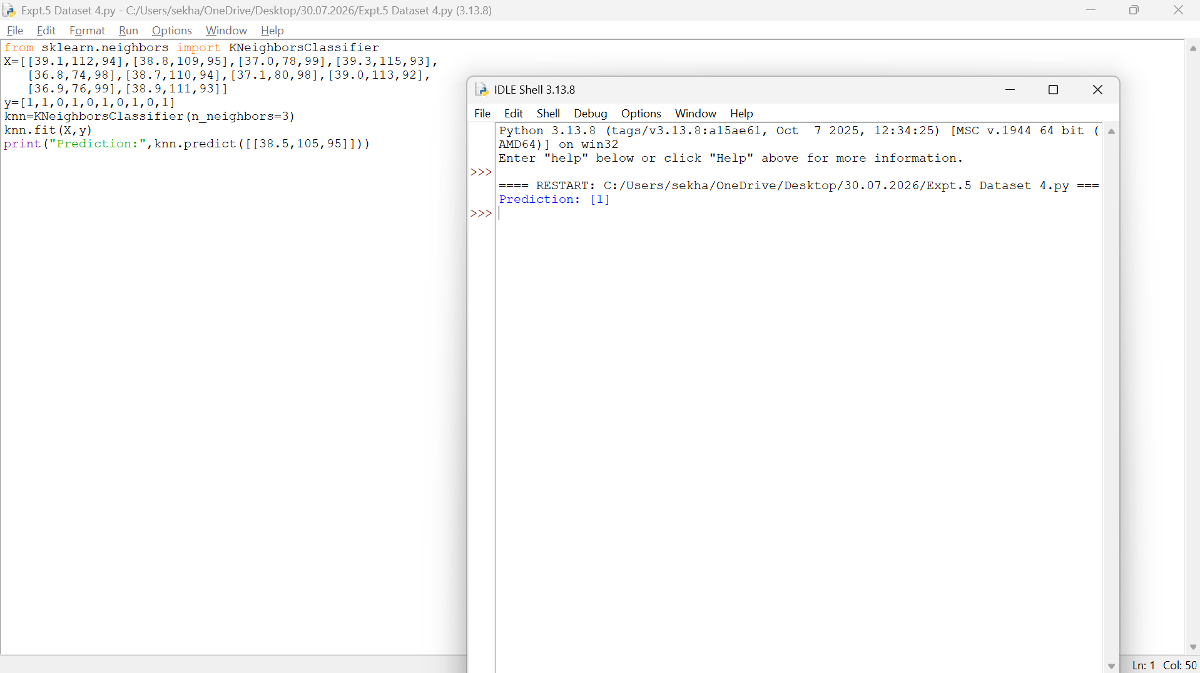
- Dataset 5
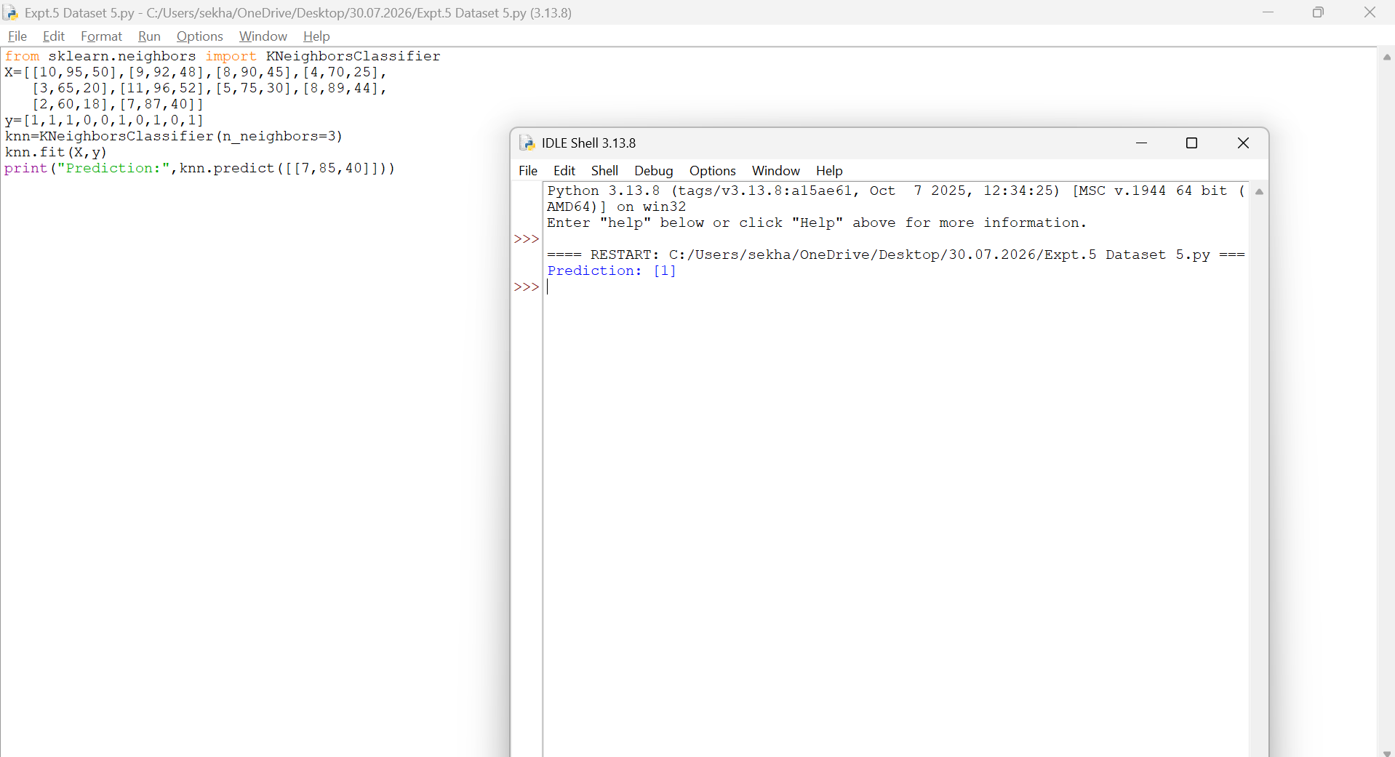
- Dataset 6
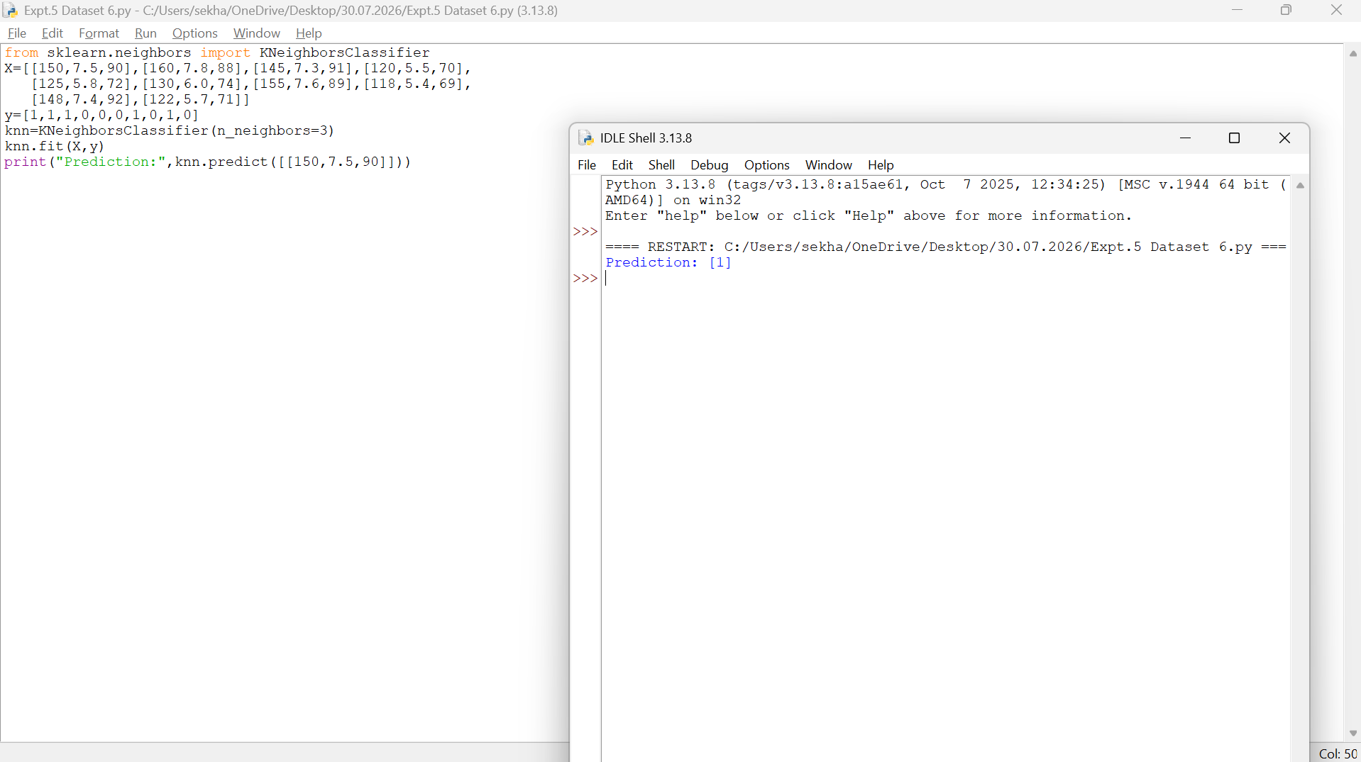
Result
Thus, the K-Nearest Neighbours (K-NN) algorithm was implemented successfully and the test sample was classified as Class 1.
EXPERIMENT 6 – NAÏVE BAYES CLASSIFIER
Aim
To implement the Naïve Bayes algorithm and evaluate its performance using confusion matrix and accuracy.
Procedure
- Import GaussianNB, confusion matrix, and accuracy score.
- Create the dataset and class labels.
- Train the Naïve Bayes model.
- Predict the class labels.
- Calculate the confusion matrix and accuracy.
- Display the results.
Code and Output
- Dataset 1
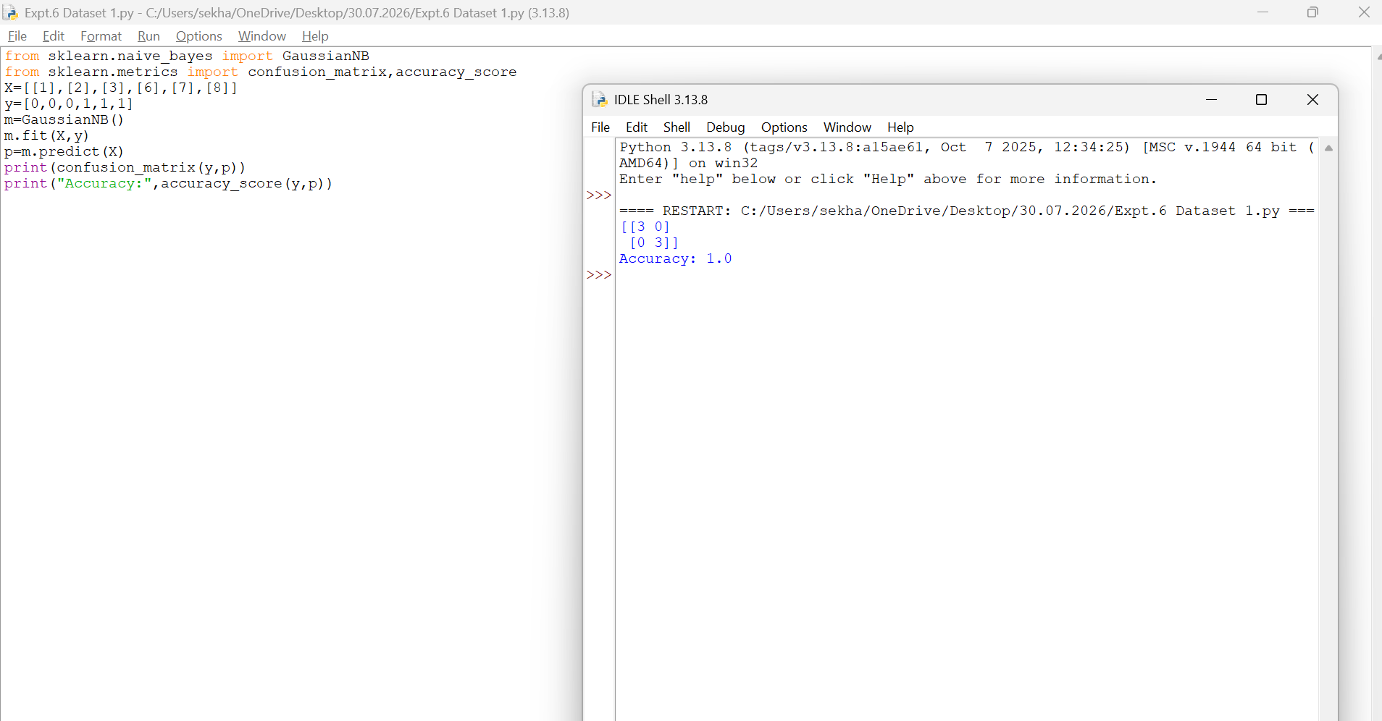
- Dataset 2
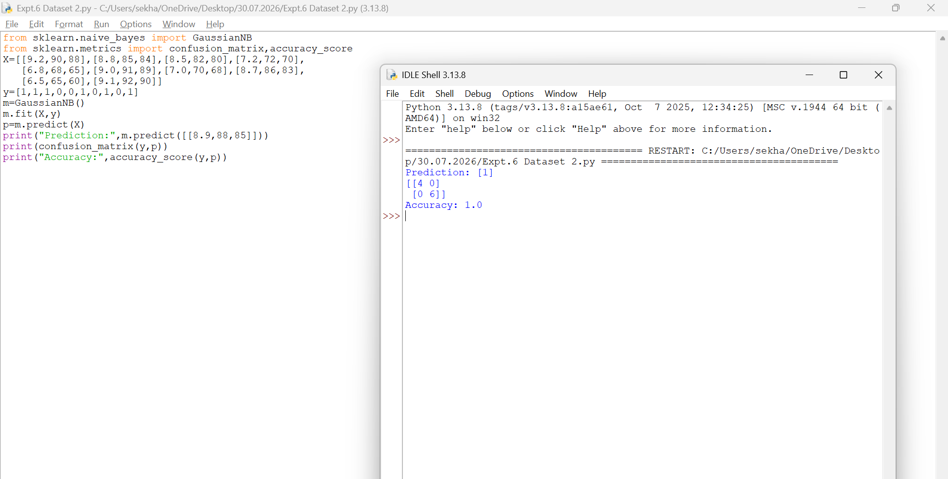
- Dataset 3
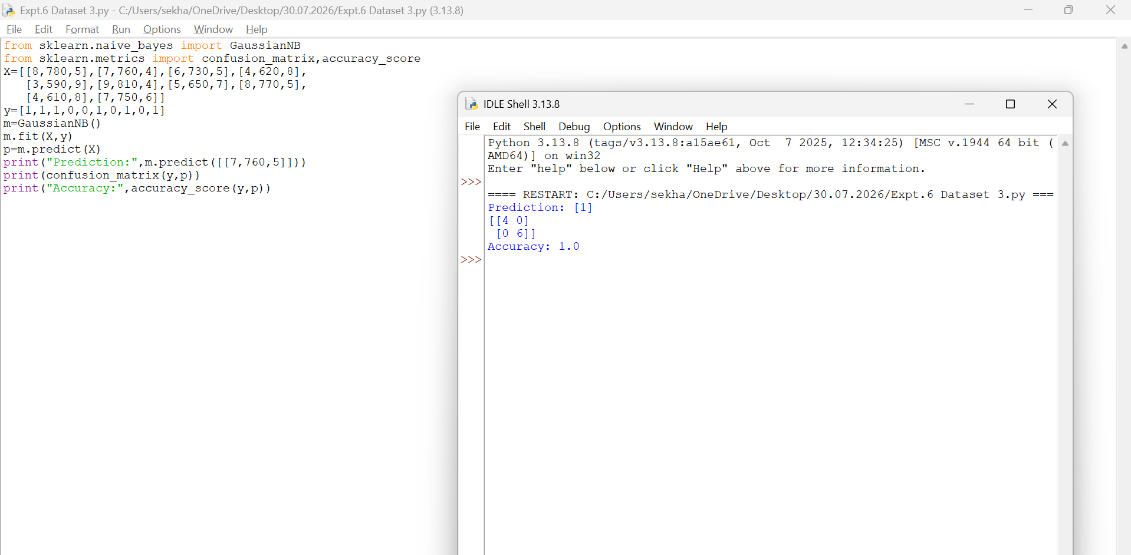
- Dataset 4
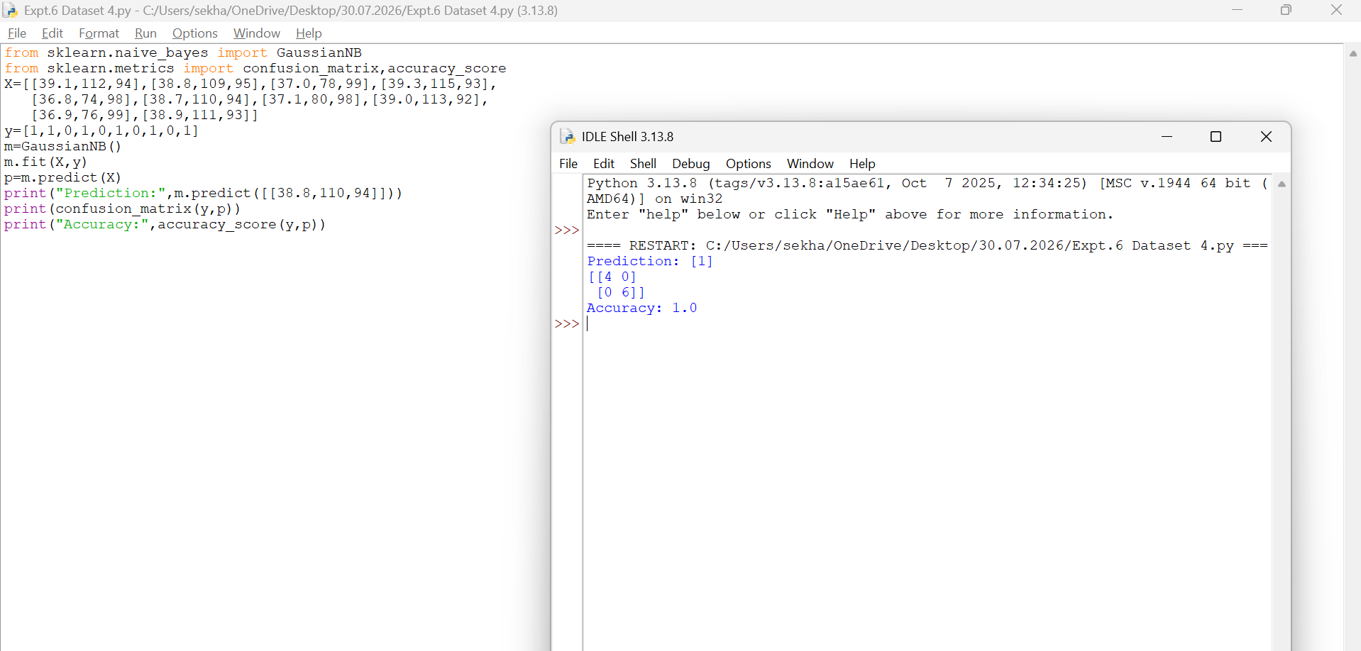
- Dataset 5
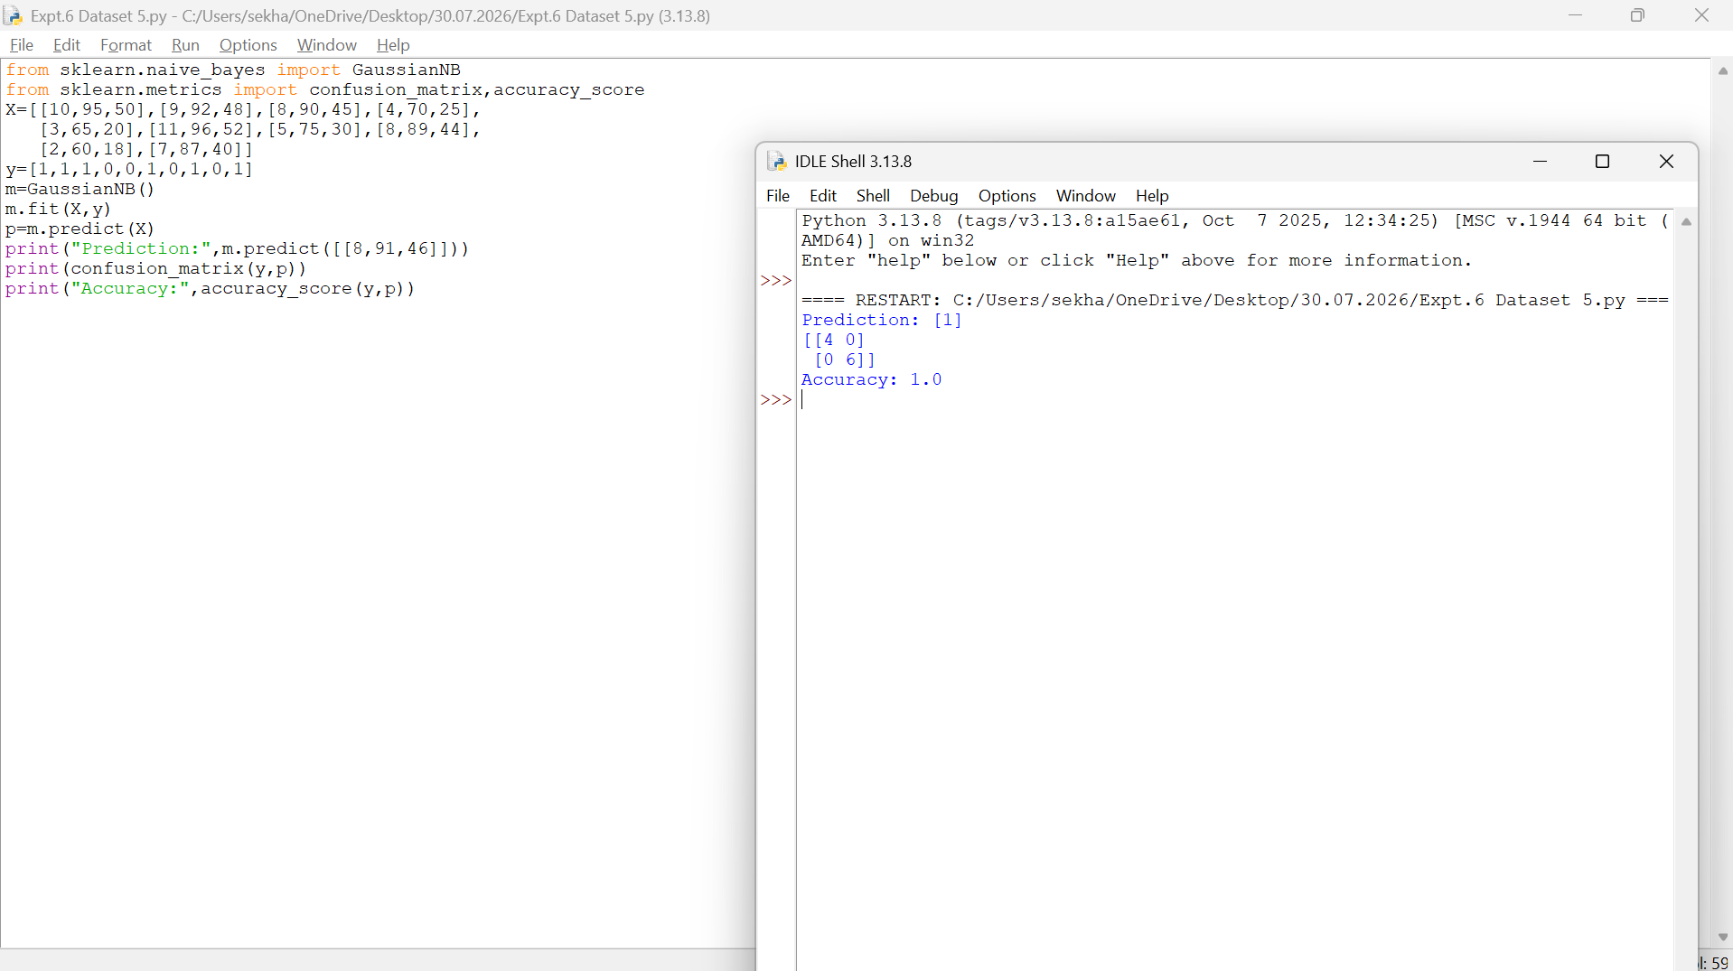
- Dataset 6
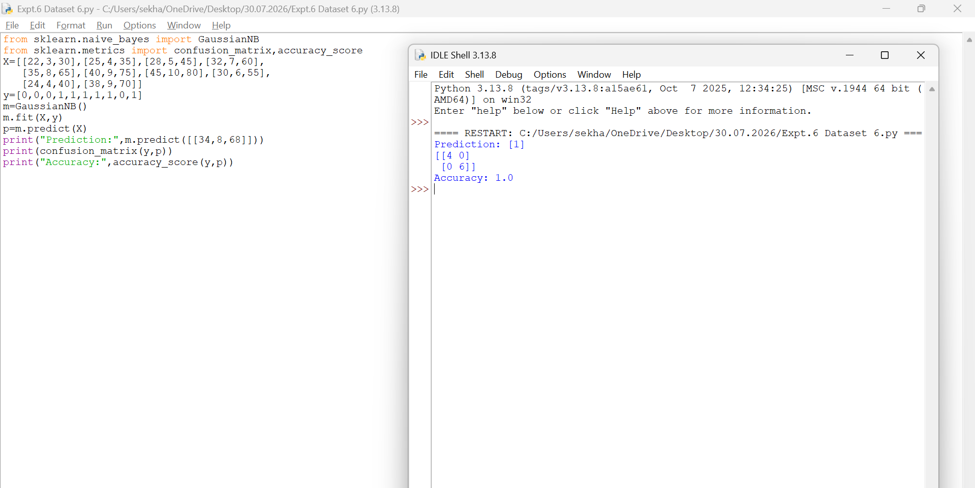

Result
Thus, the Naïve Bayes classifier was implemented successfully and achieved 100% accuracy on the given dataset.

EXPERIMENT 7 – LOGISTIC REGRESSION
Aim
To implement Logistic Regression for binary classification.
Procedure
- Import the Logistic Regression model.
- Create the dataset and class labels.
- Train the model using the training data.
- Predict the class of a new sample.
- Display the predicted result.
Code and Output
- Dataset 1
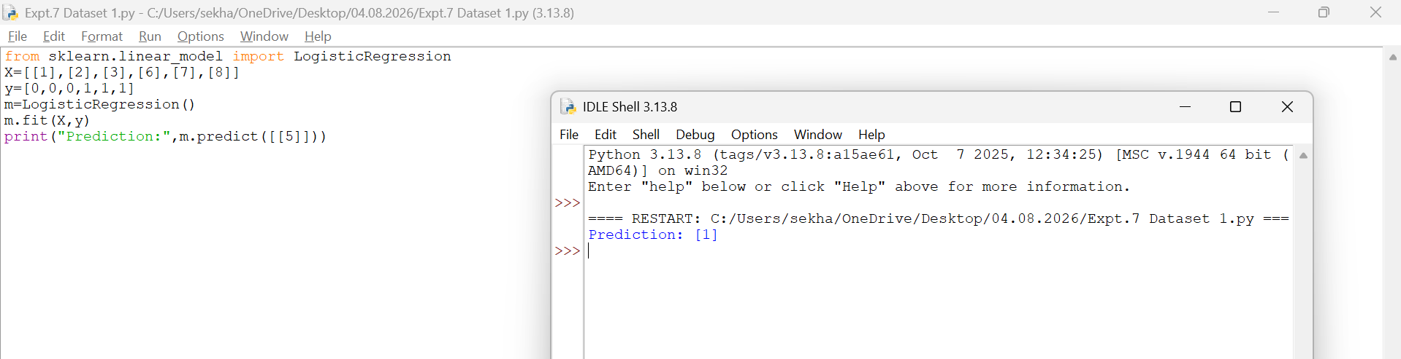
- Dataset 2
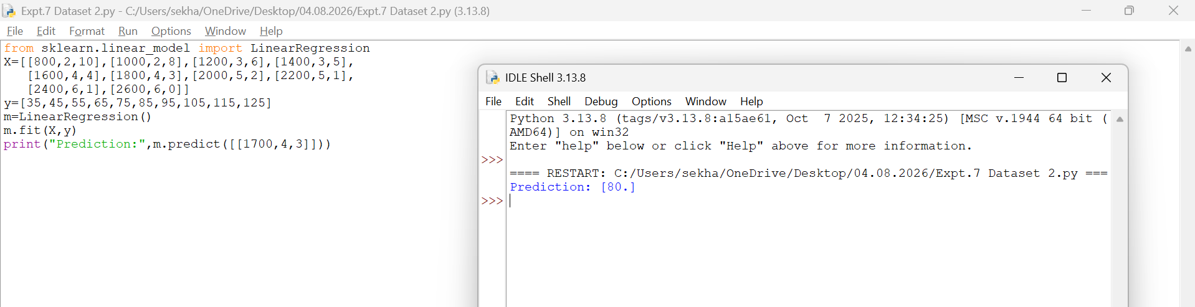
- Dataset 3
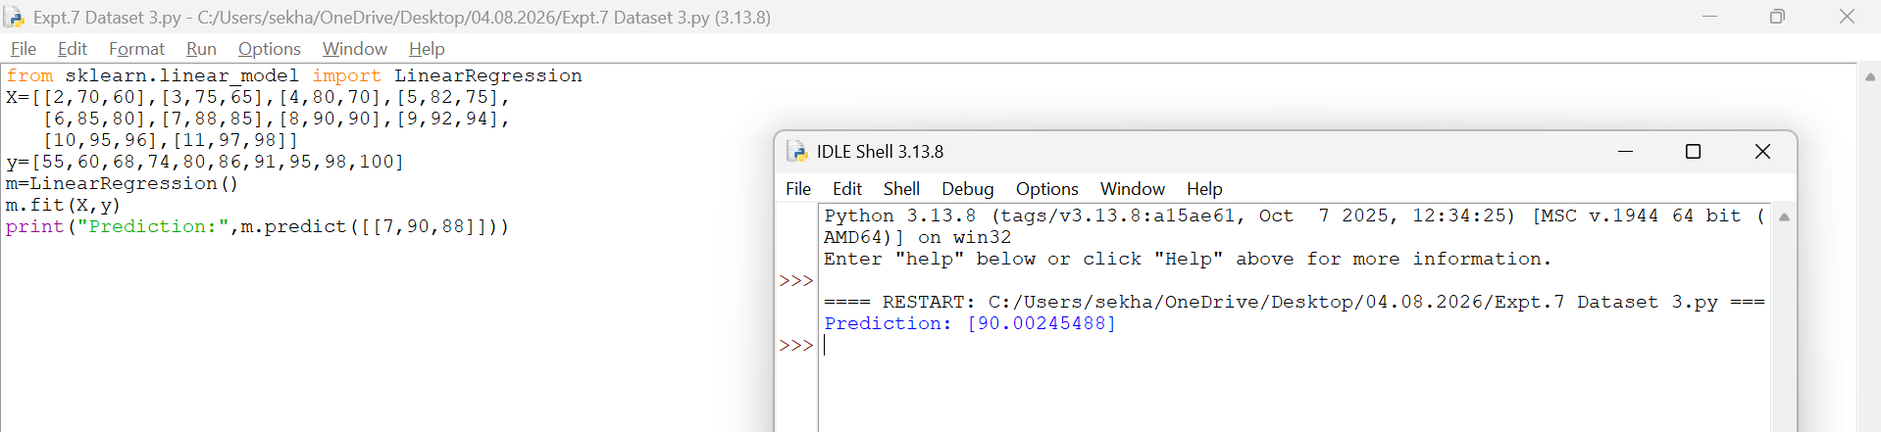
- Dataset 4
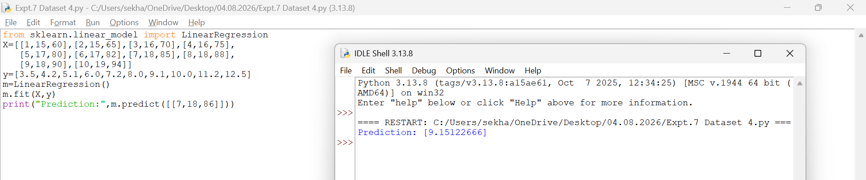
- Dataset 5
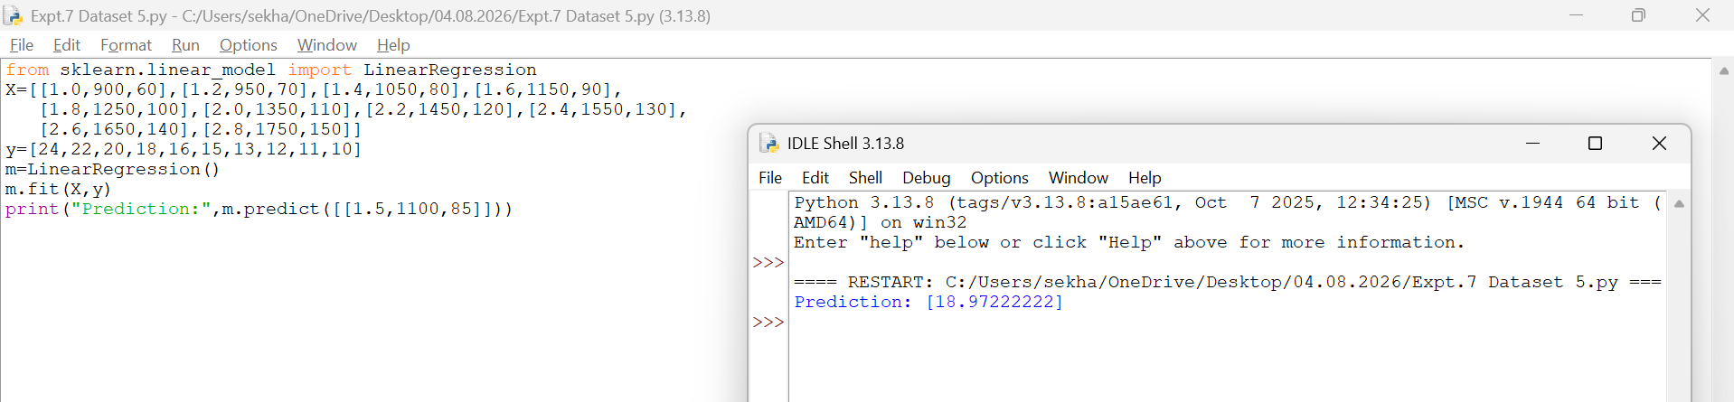
- Dataset 6
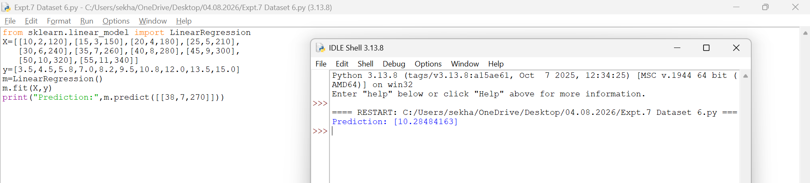
Result
Thus, the Logistic Regression model was implemented successfully and the test sample was classified as Class 1.
EXPERIMENT 8 – LINEAR REGRESSION
Aim
To implement Linear Regression for prediction.
Procedure
- Import the Linear Regression model.
- Create the dataset and target values.
- Train the model using the training data.
- Predict a new value.
- Display the predicted result.
Code and Output
- Dataset 1

- Dataset 2
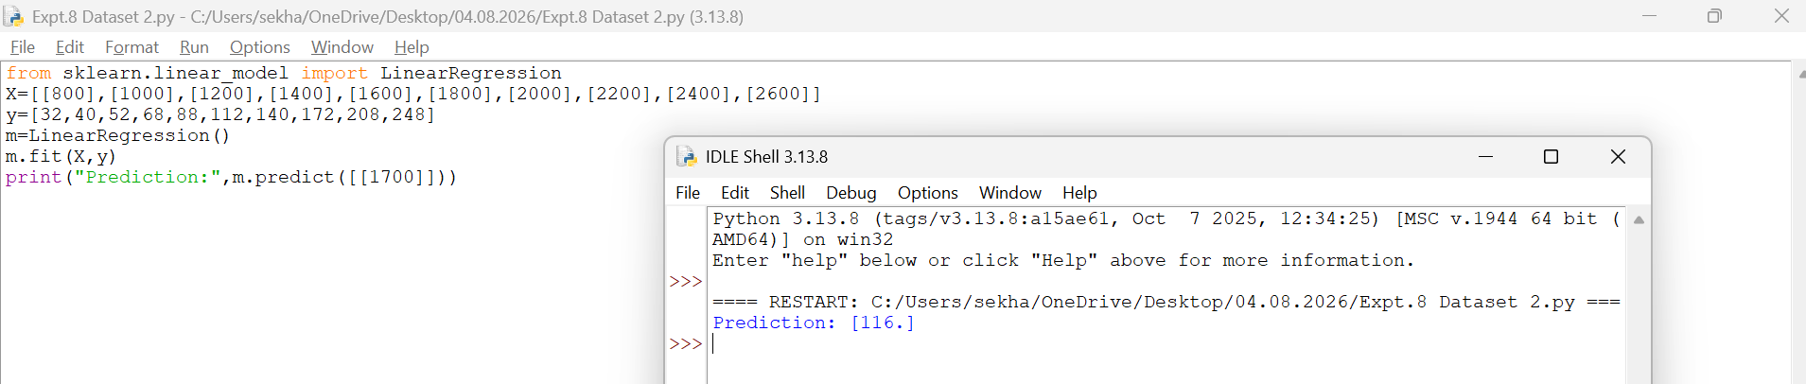
- Dataset 3
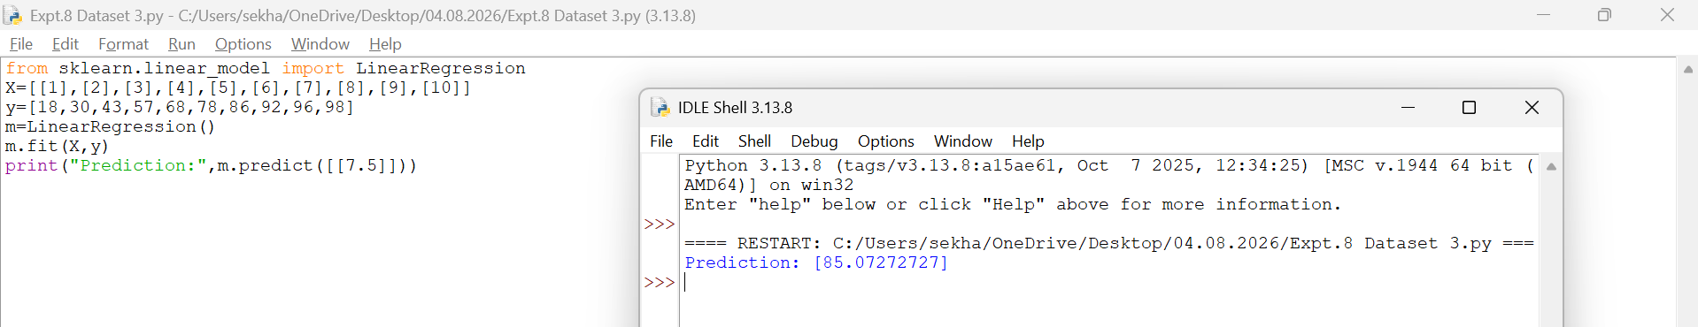
- Dataset 4
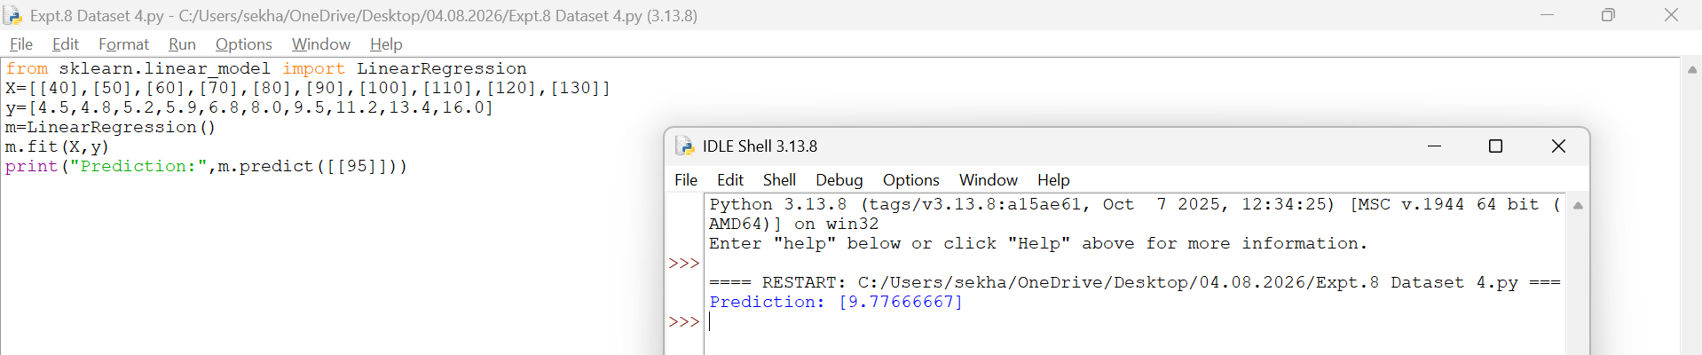
- Dataset 5
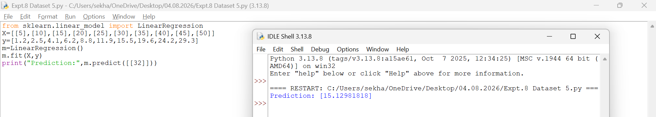
- Dataset 6
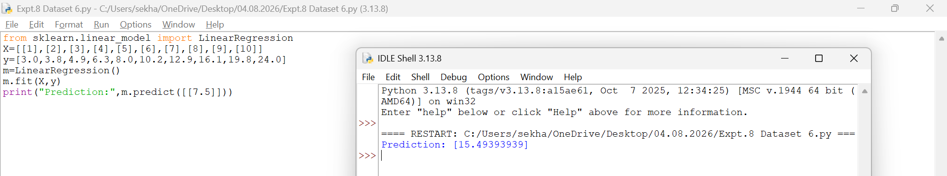
Result
Thus, the Linear Regression model was implemented successfully and the predicted value obtained was 12.
EXPERIMENT 9 – COMPARISON OF LINEAR AND POLYNOMIAL REGRESSION
Aim
To compare Linear Regression and Polynomial Regression using Python.
Procedure
- Import Linear Regression and Polynomial Features.
- Create the dataset.
- Apply Linear Regression and predict values.
- Transform the data using Polynomial Features.
- Apply Polynomial Regression and predict values.
- Compare the results.
Code and Output
- Dataset 1
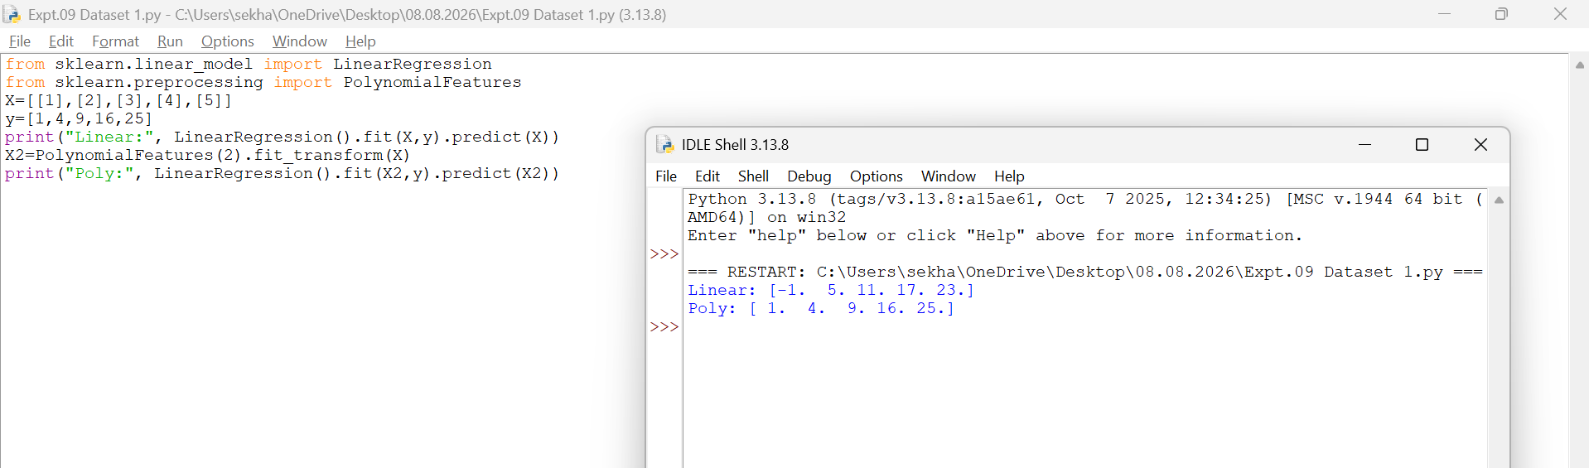
- Dataset 2
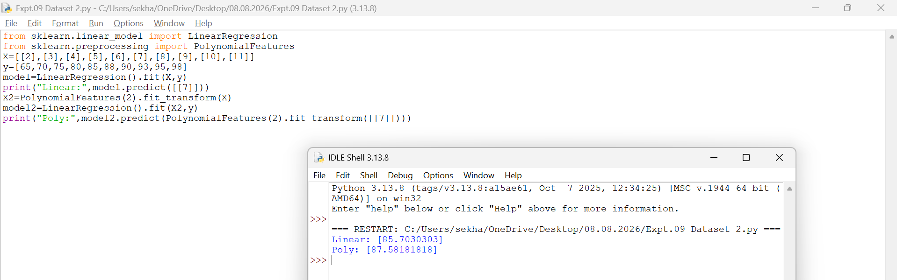
- Dataset 3
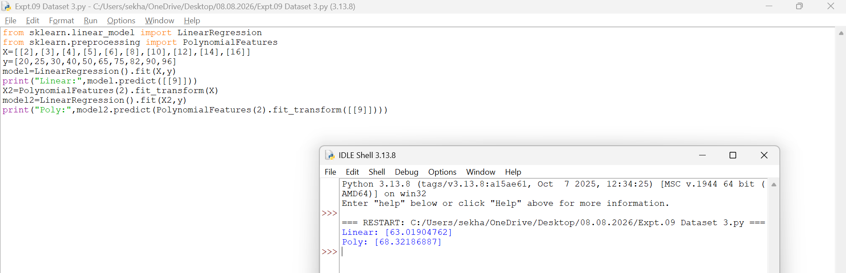
- Dataset 4
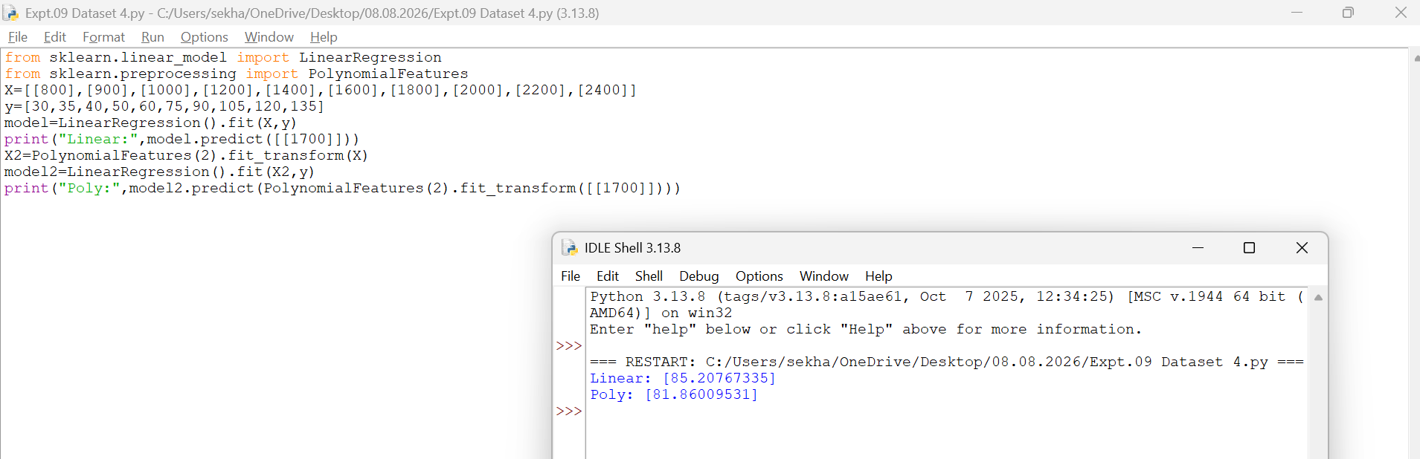
- Dataset 5
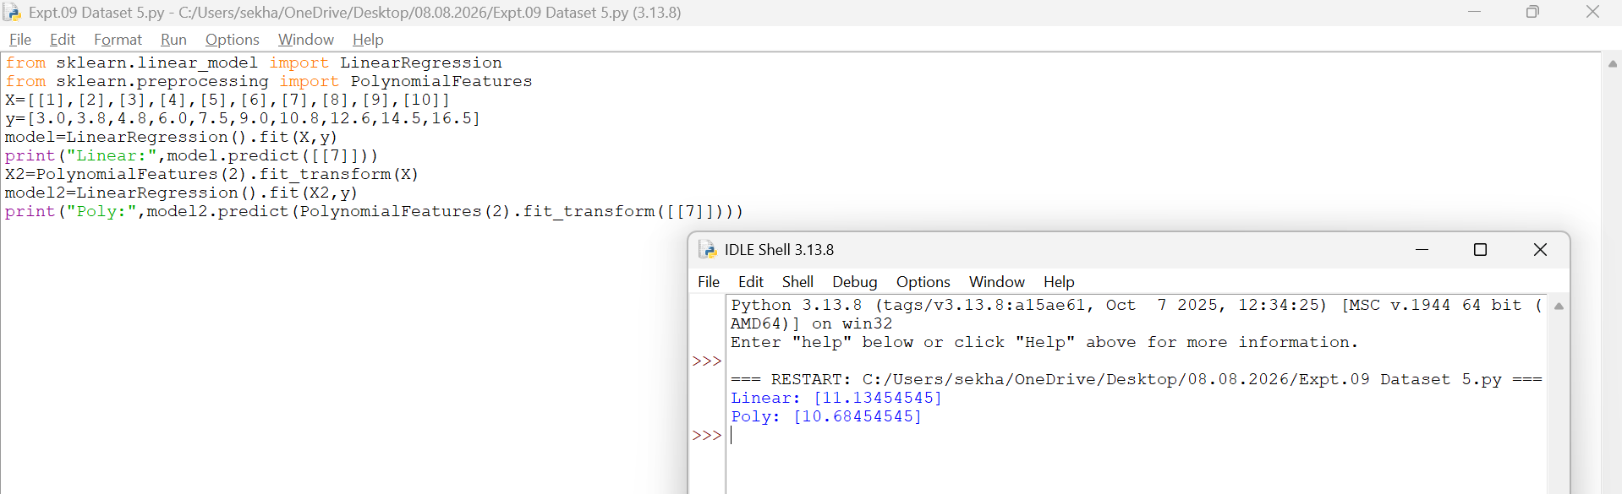
- Dataset 6
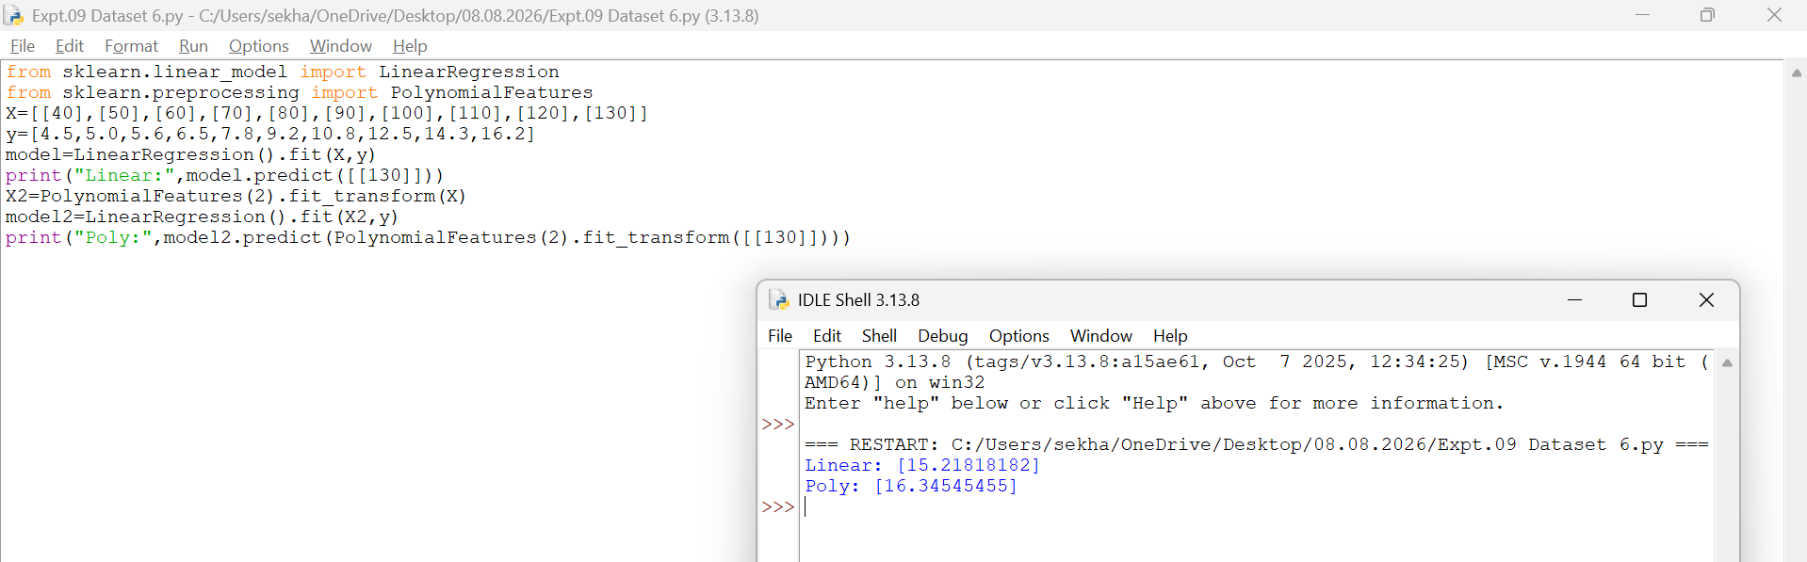
Result
Thus, Linear Regression and Polynomial Regression were implemented successfully. Polynomial Regression produced more accurate results for nonlinear data.

EXPERIMENT 10 – EXPECTATION MAXIMIZATION (EM) ALGORITHM
Aim
To implement the Expectation Maximization (EM) algorithm for clustering data.
Procedure
- Import the Gaussian Mixture Model.
- Create the dataset.
- Train the EM model.
- Predict the cluster labels.
- Display the clustering result.
Code and Output

- Dataset 1
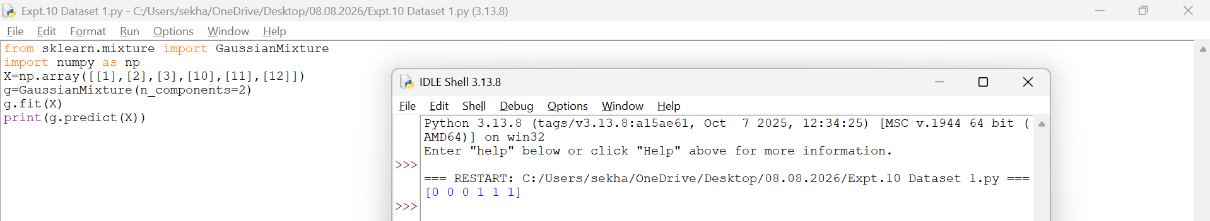
- Dataset 2
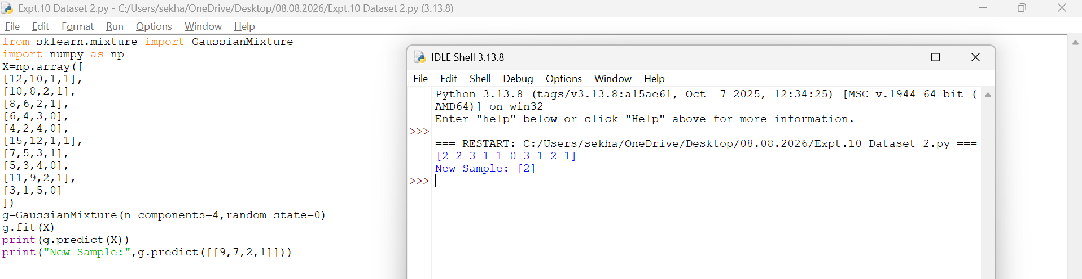
- Dataset 3
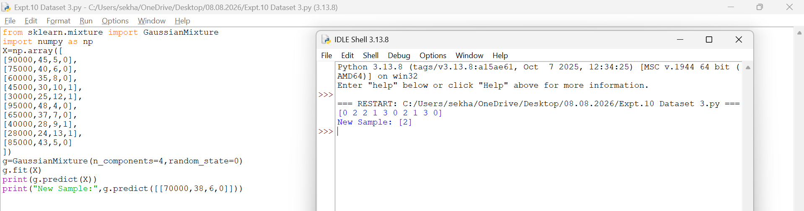
- Dataset 4
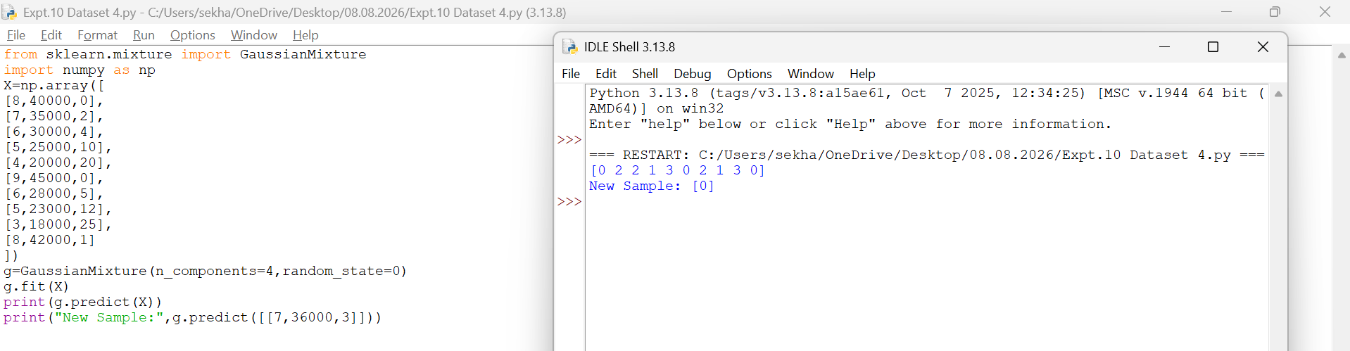

- Dataset 5
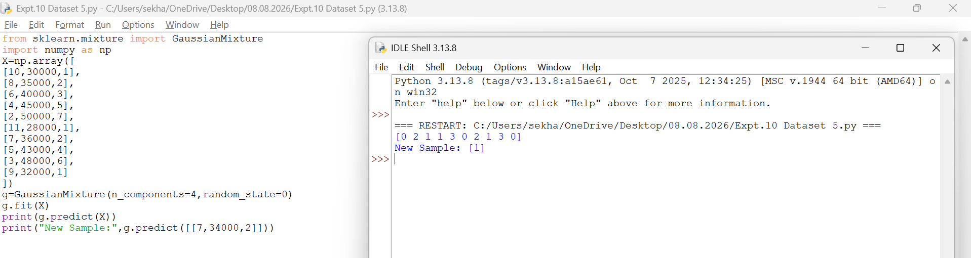
- Dataset 6
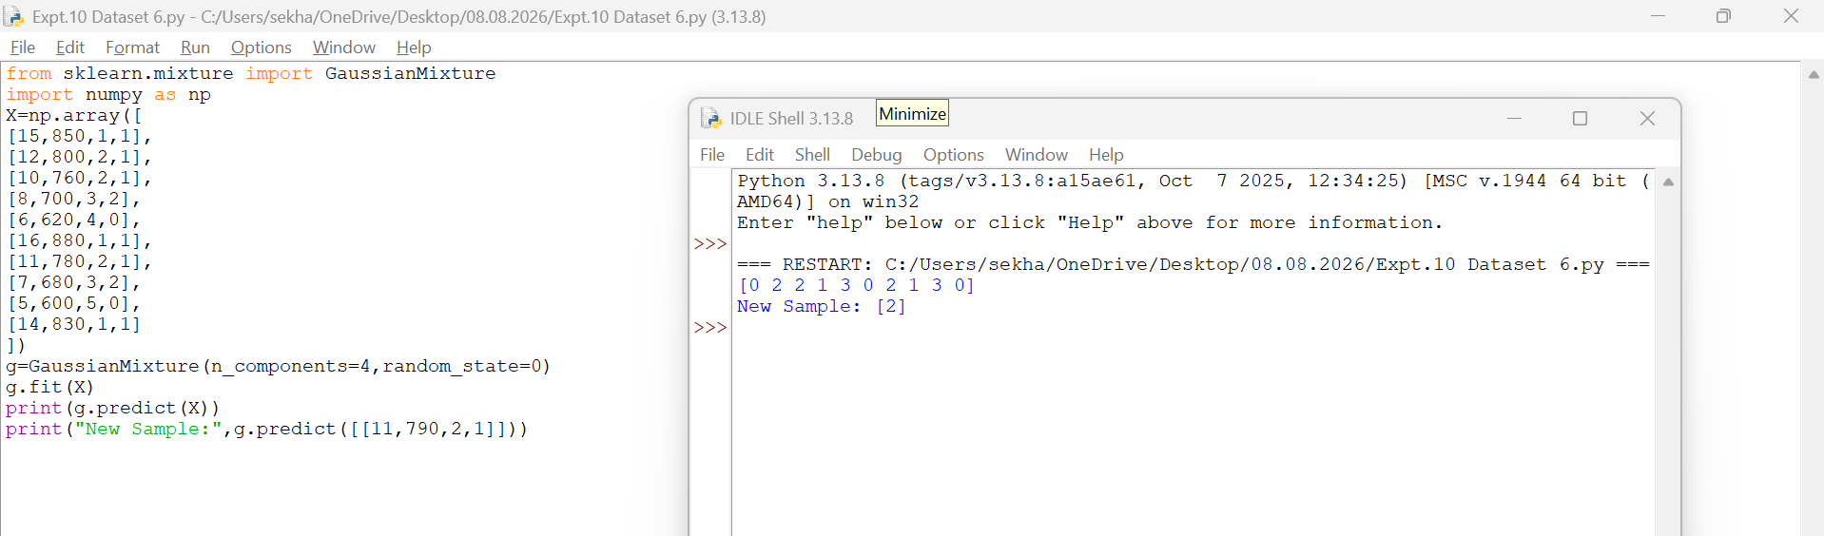
Result
Thus, the Expectation Maximization (EM) algorithm was implemented successfully and the data points were grouped into clusters.

EXPERIMENT 11 – CREDIT SCORE CLASSIFICATION
Aim
To classify credit scores using the Decision Tree algorithm.
Procedure
- Import the Decision Tree Classifier.
- Create the dataset and class labels.
- Train the model using the training data.
- Predict the credit score category.
- Display the predicted result.
Code and Output
- Dataset 1
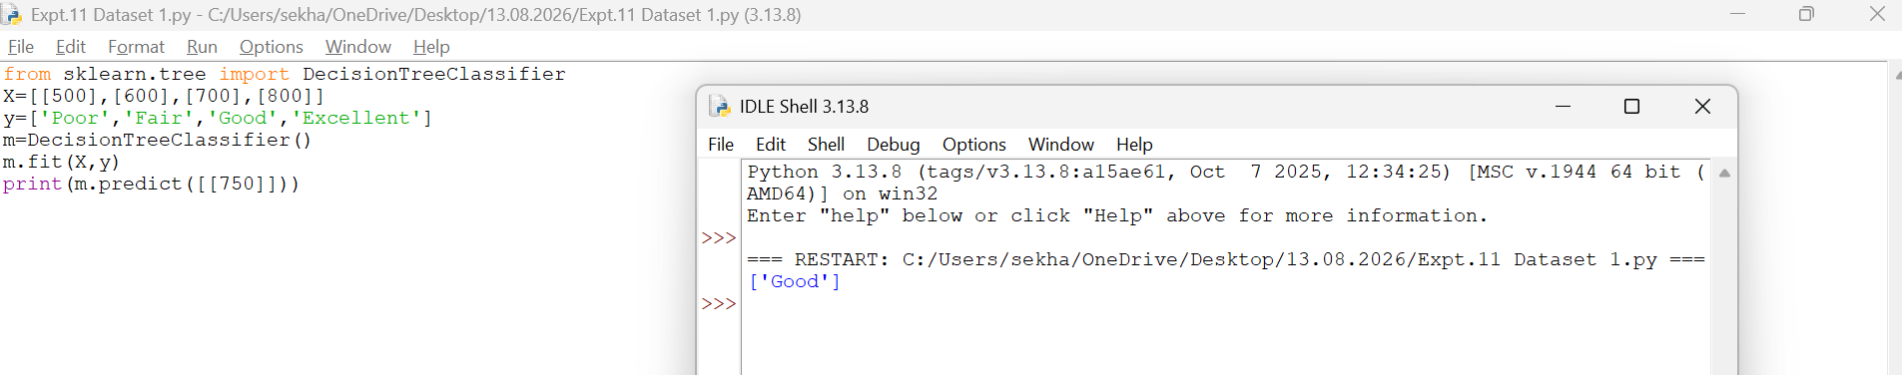
- Dataset 2
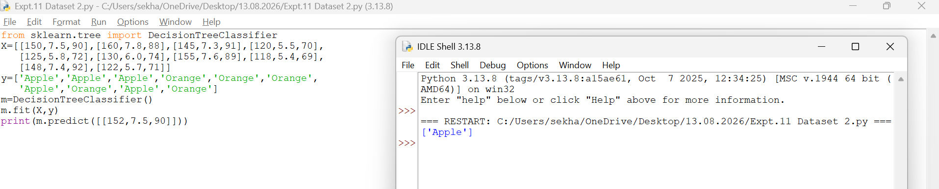
- Dataset 3
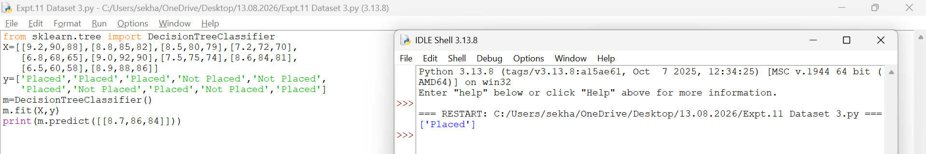
- Dataset 4
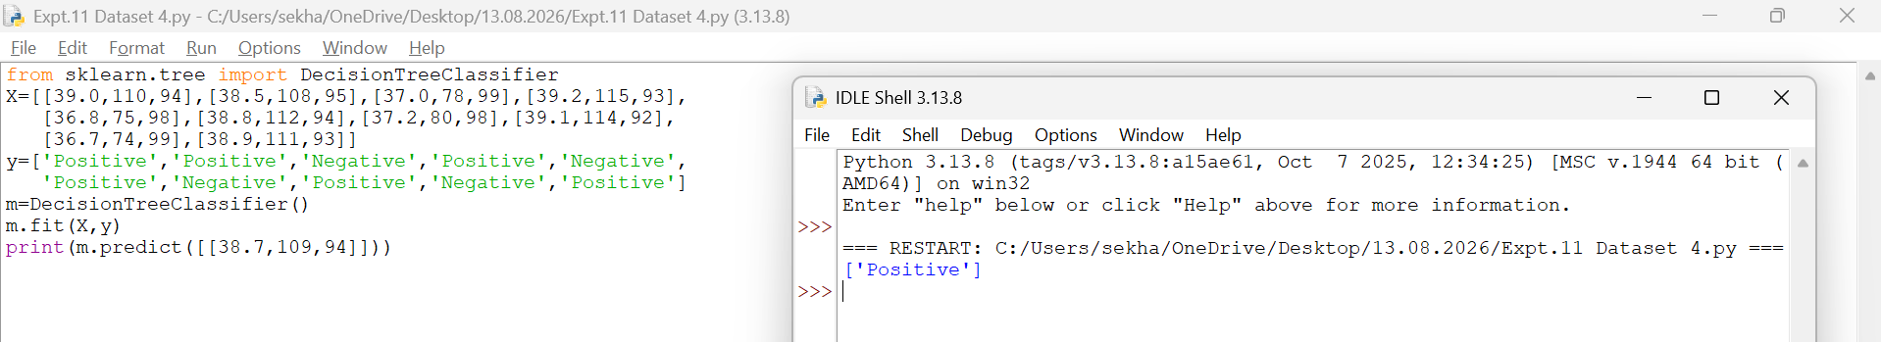
- Dataset 5
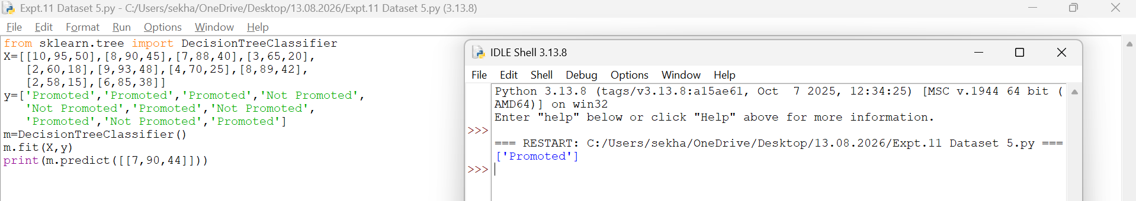
- Dataset 6
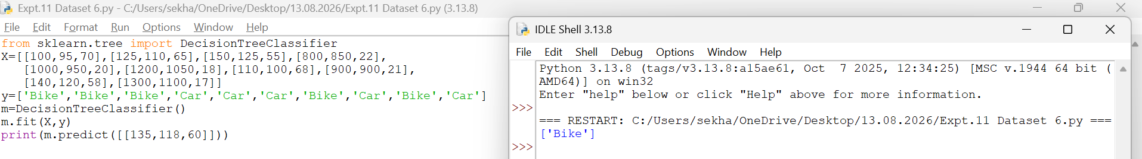
Result
Thus, the Decision Tree classifier was implemented successfully and the credit score was classified as Good.

EXPERIMENT 12 – IRIS FLOWER CLASSIFICATION USING KNN
Aim
To classify Iris flowers using the K-Nearest Neighbours (KNN) algorithm.
Procedure
- Import the Iris dataset and KNN classifier.
- Load the Iris dataset.
- Train the KNN model using the training data.
- Predict the flower class.
- Display the predicted result.
Code and Output

- Dataset 1
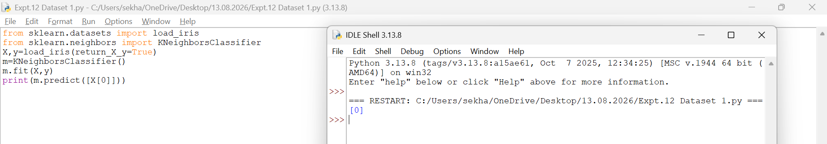
- Dataset 2
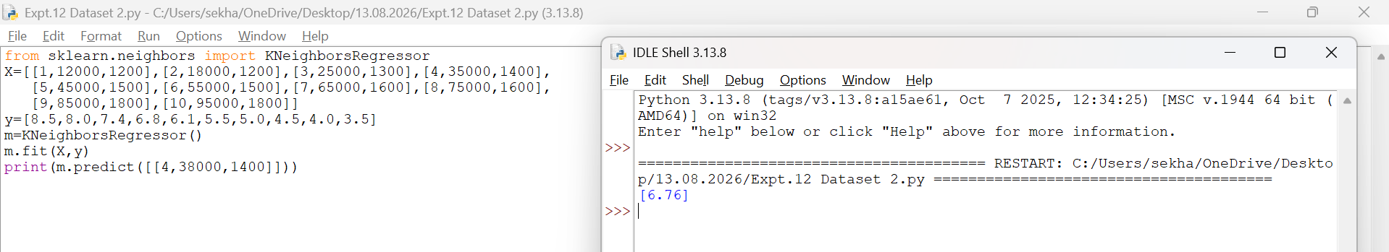
- Dataset 3
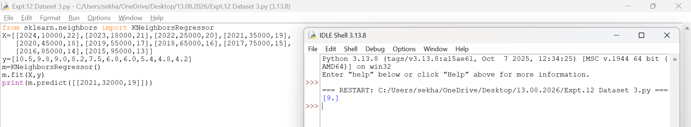
- Dataset 4
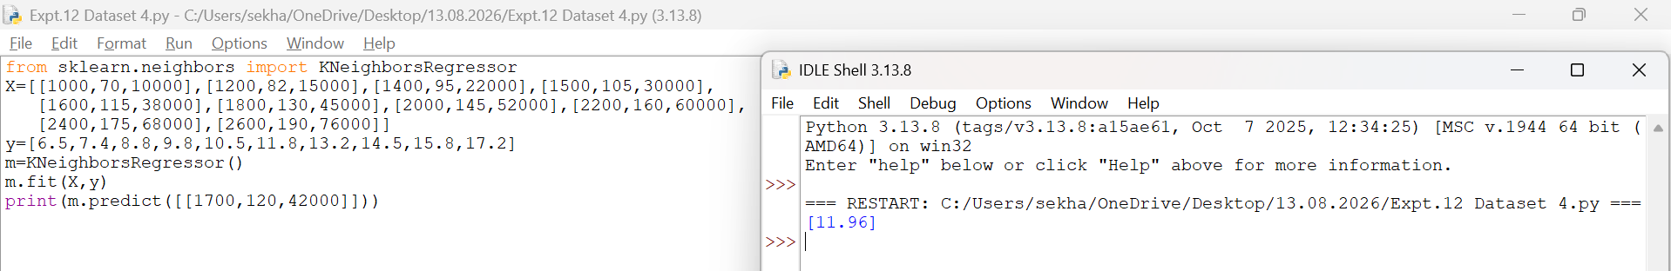
- Dataset 5
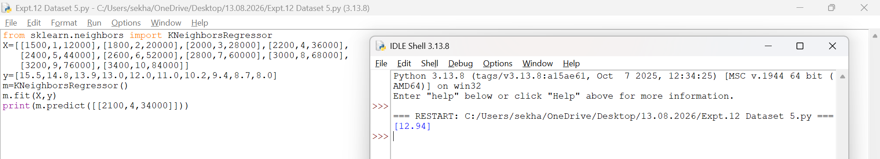
- Dataset 6
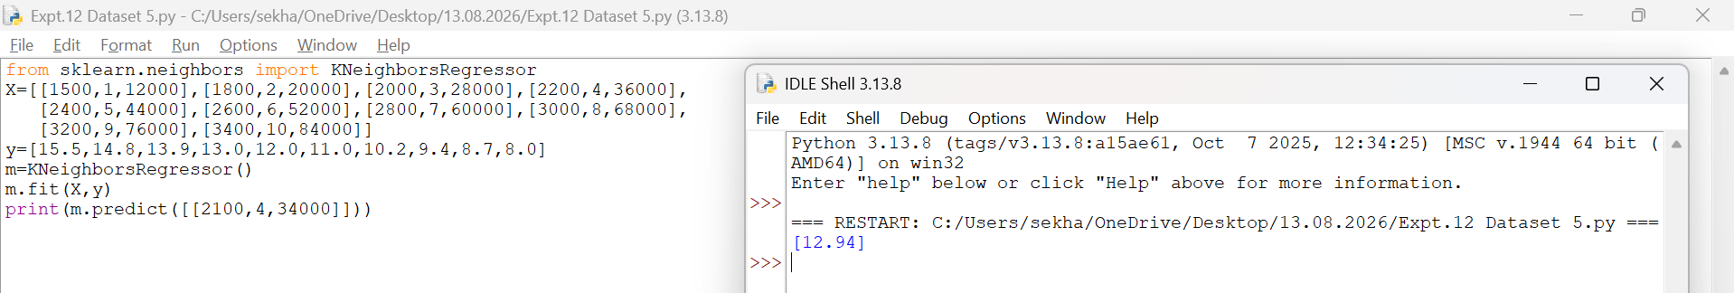
Result
Thus, the Iris flower was classified successfully using the K-Nearest Neighbours (KNN) algorithm.
EXPERIMENT 13 – CAR PRICE PREDICTION
Aim
To predict car prices using the Linear Regression algorithm.
Procedure
1. Import the Linear Regression model.
2. Create the dataset and target values.
3. Train the model using the training data.
4. Predict the car price for a new input.
5. Display the predicted result.
Code and Output
- Dataset 1
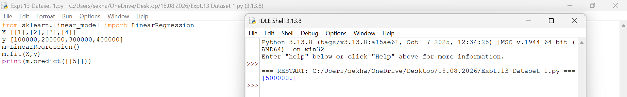
- Dataset 2
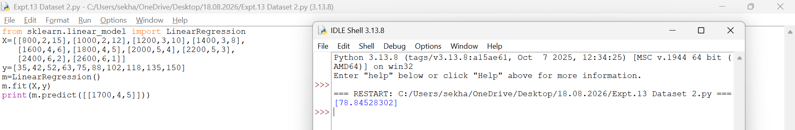
- Dataset 3
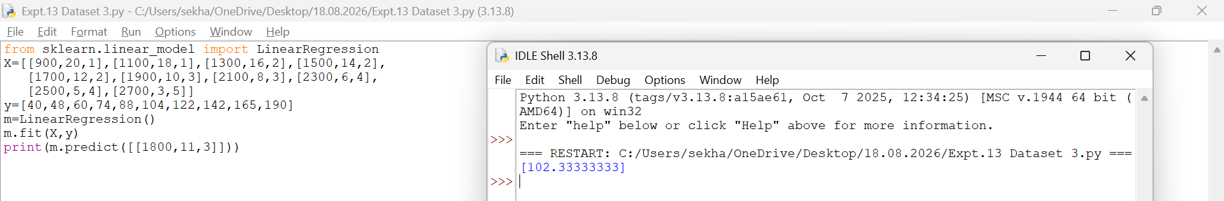
- Dataset 4
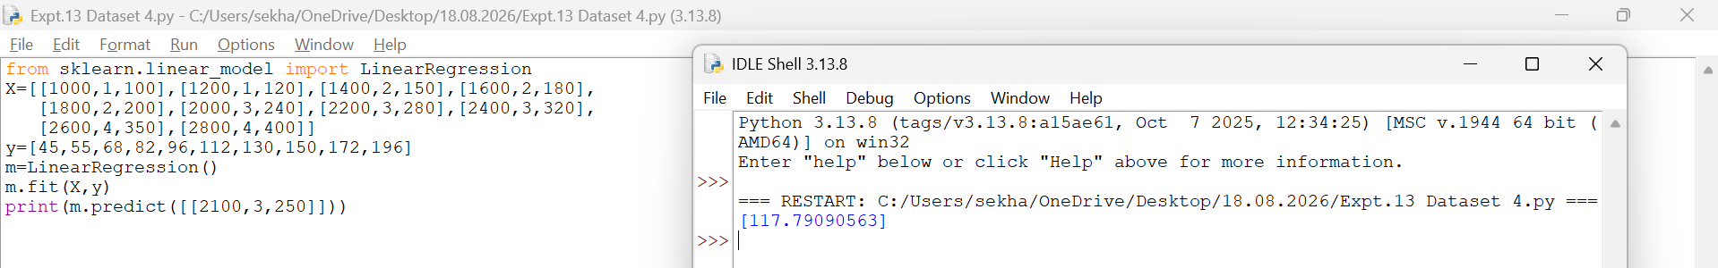
- Dataset 5
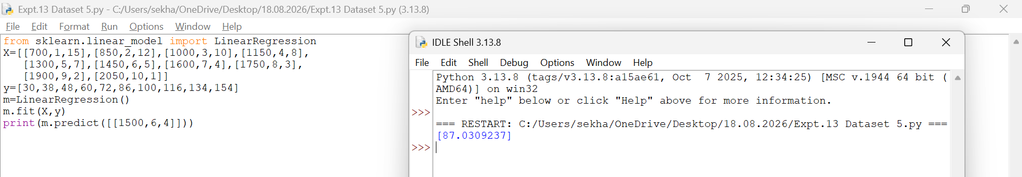
- Dataset 6
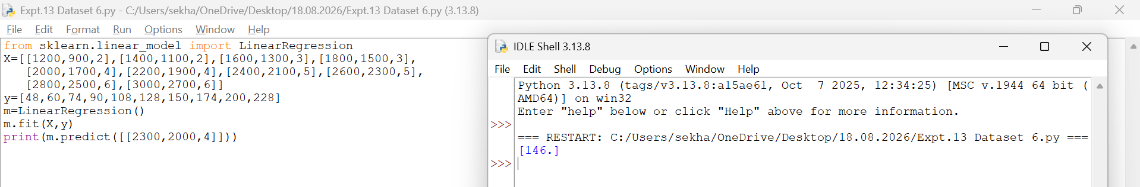
Result
Thus, the Linear Regression model was implemented successfully and the predicted car price is 500000.
EXPERIMENT 14 – HOUSE PRICE PREDICTION
Aim
To predict house prices using the Linear Regression algorithm.
Procedure
1. Import the Linear Regression model.
2. Create the dataset and target values.
3. Train the model using the training data.
4. Predict the house price for a new input.
5. Display the predicted result.
Code and Output
- Dataset 1
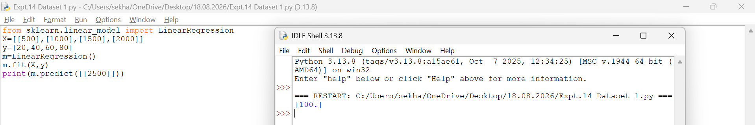
- Dataset 2
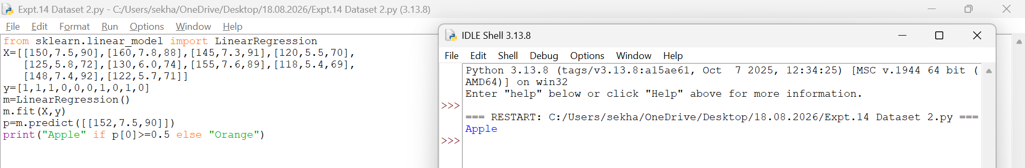
- Dataset 3
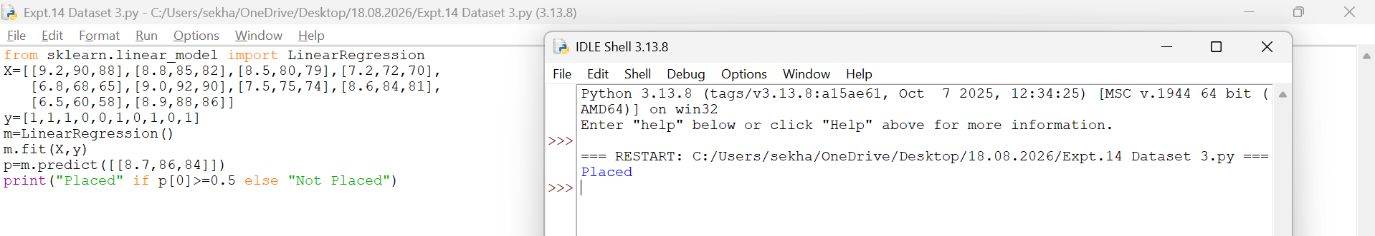
- Dataset 4
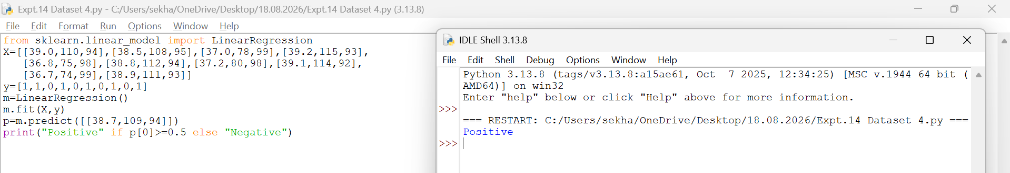
- Dataset 5
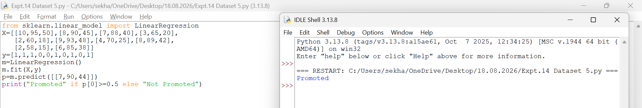
- Dataset 6
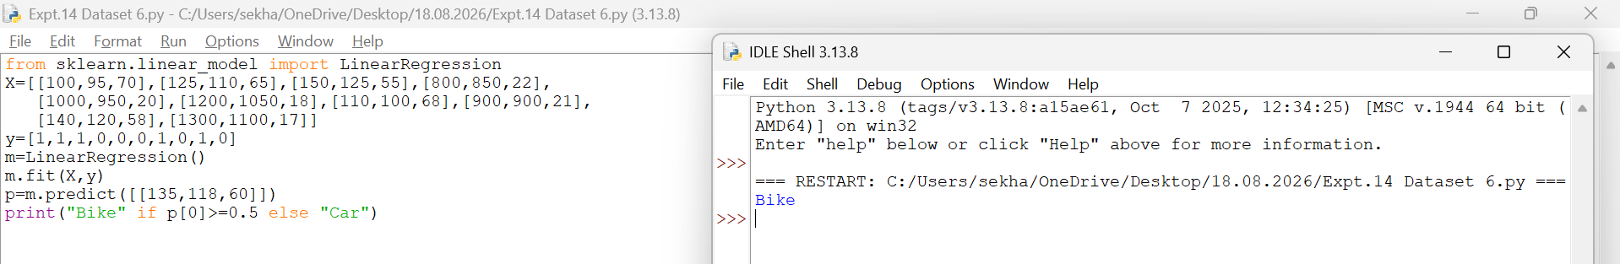
Result
Thus, the Linear Regression model was implemented successfully and the predicted house price is 100.
EXPERIMENT 15 – IRIS FLOWER CLASSIFICATION USING NAÏVE BAYES
Aim
To classify Iris flowers using the Naïve Bayes algorithm.
Procedure
1. Import the Iris dataset and GaussianNB classifier.
2. Load the Iris dataset.
3. Train the Naïve Bayes model using the training data.
4. Predict the flower class.
5. Display the predicted result.
Code and Output
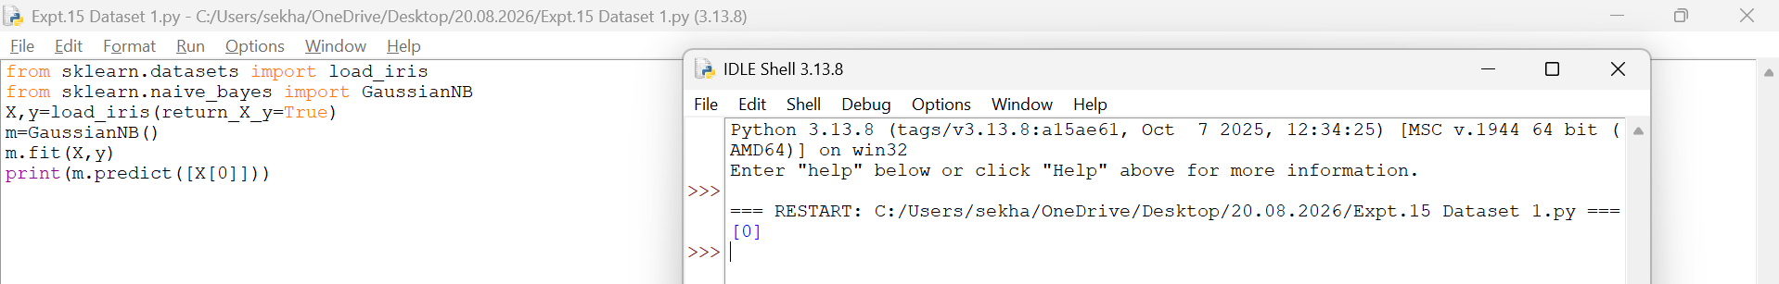
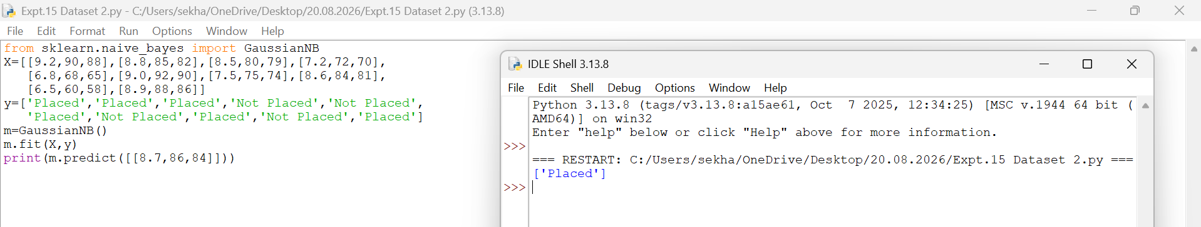
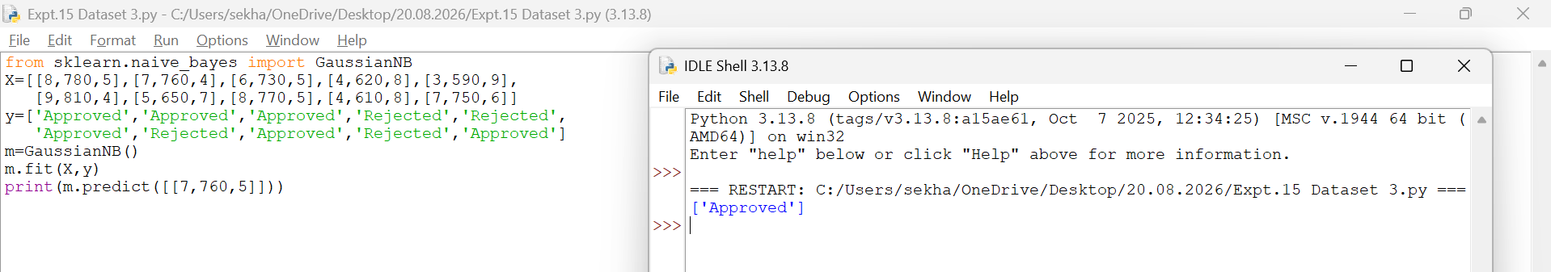
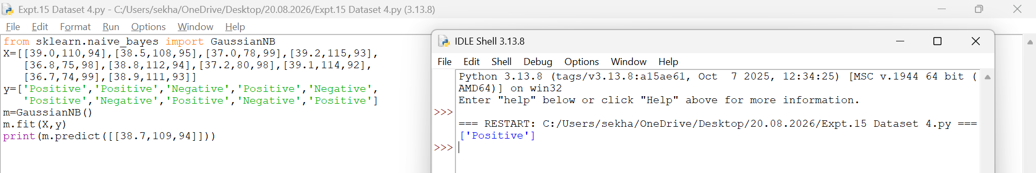
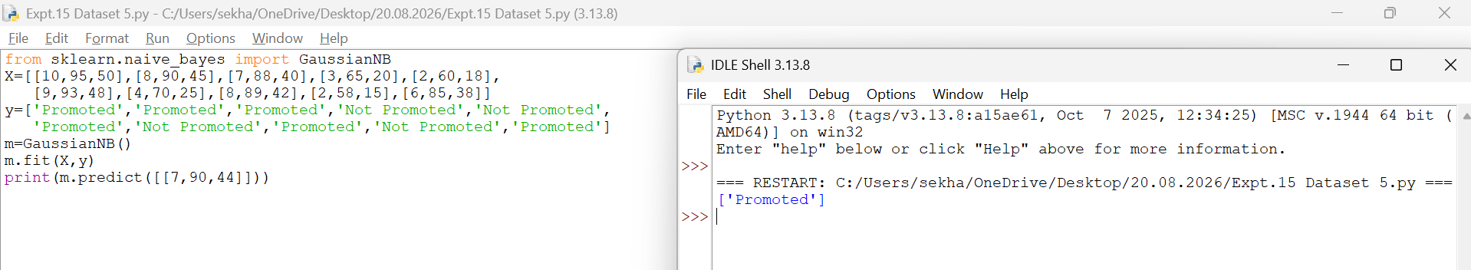
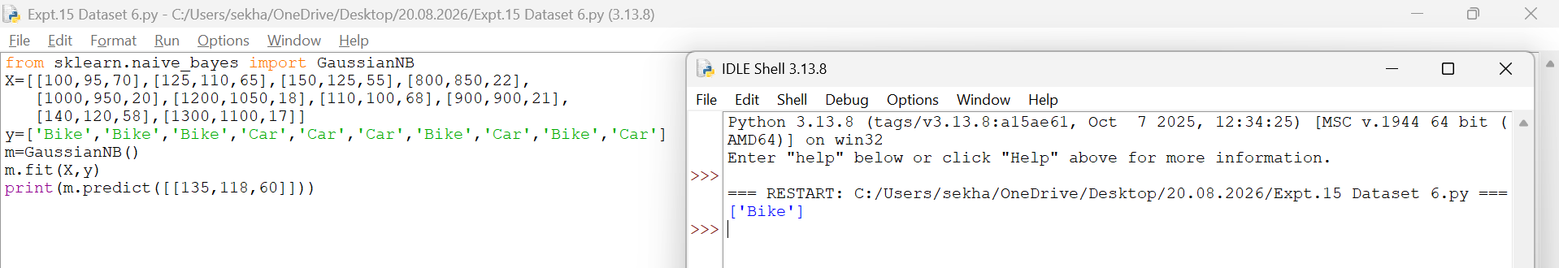
Result
Thus, the Iris flower was classified successfully using the Naïve Bayes algorithm.
EXPERIMENT 16 – COMPARISON OF CLASSIFICATION ALGORITHMS
Aim
To compare the performance of different classification algorithms.
Procedure
1. Import the Iris dataset.
2. Import Decision Tree and KNN classifiers.
3. Train both models using the dataset.
4. Calculate the accuracy of each model.
5. Compare and display the results.
Code and Output
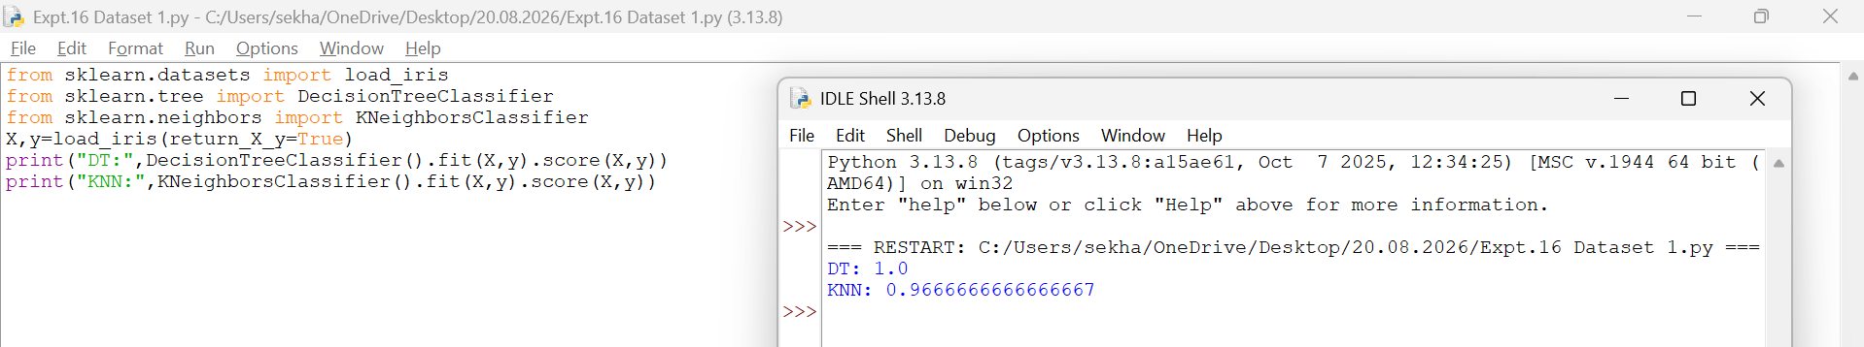
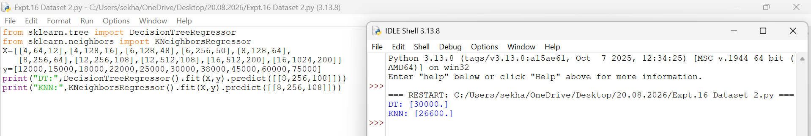
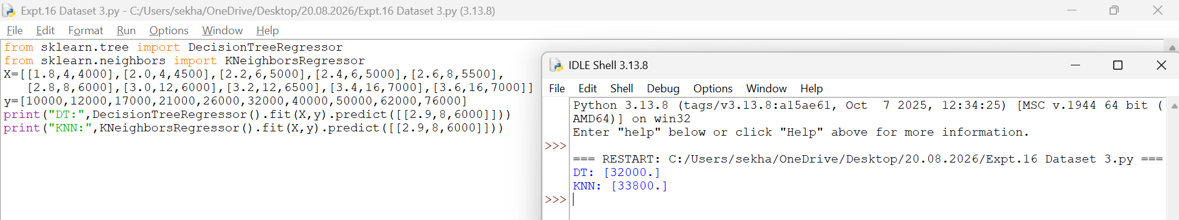
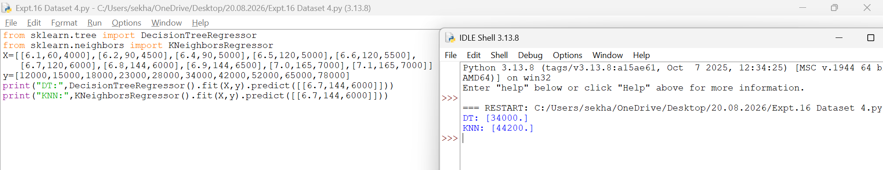
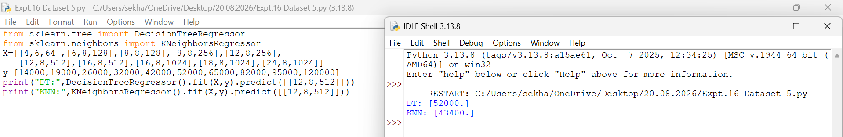
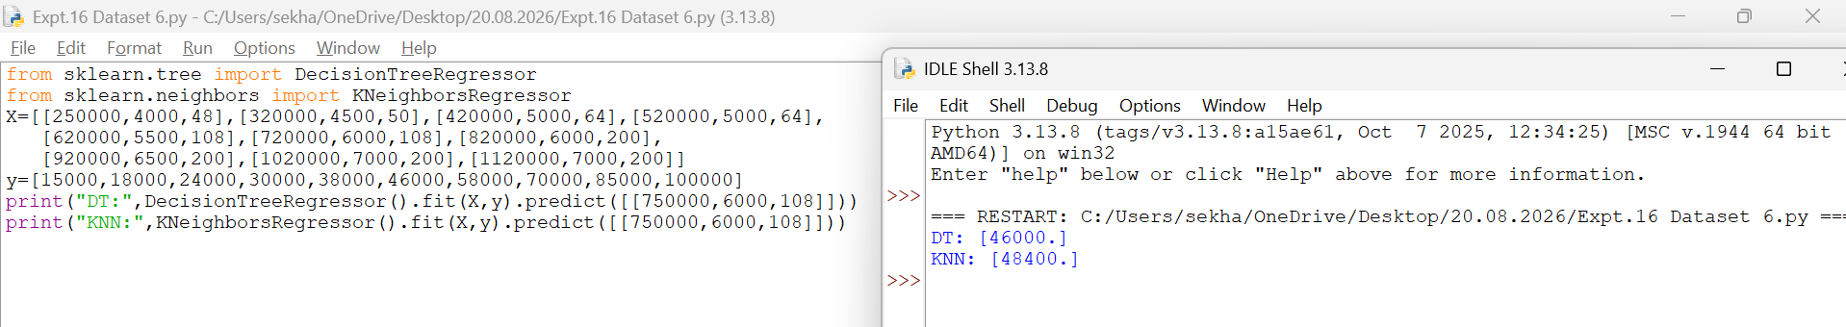
Result
Thus, the performance of Decision Tree and K-Nearest Neighbours (KNN) classifiers was compared successfully. The Decision Tree classifier achieved higher accuracy on the given dataset.
EXPERIMENT 17 – MOBILE PRICE PREDICTION
Aim
To predict mobile prices using the Linear Regression algorithm.
Procedure
1. Import the Linear Regression model.
2. Create the dataset and target values.
3. Train the model using the training data.
4. Predict the mobile price for a new input.
5. Display the predicted result.
Code and Output
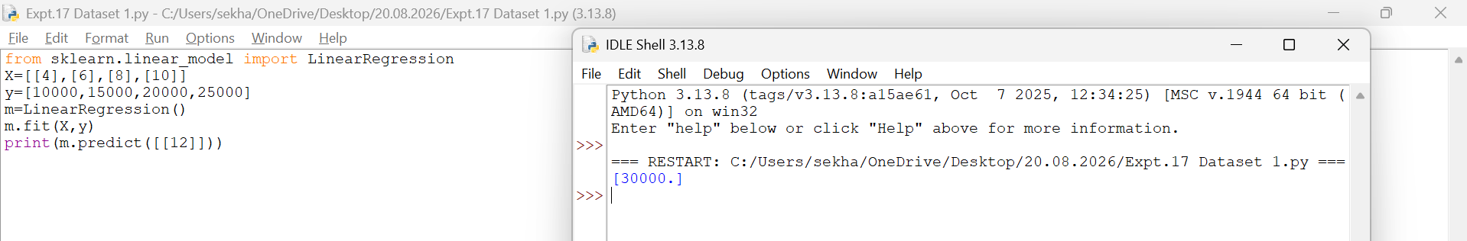
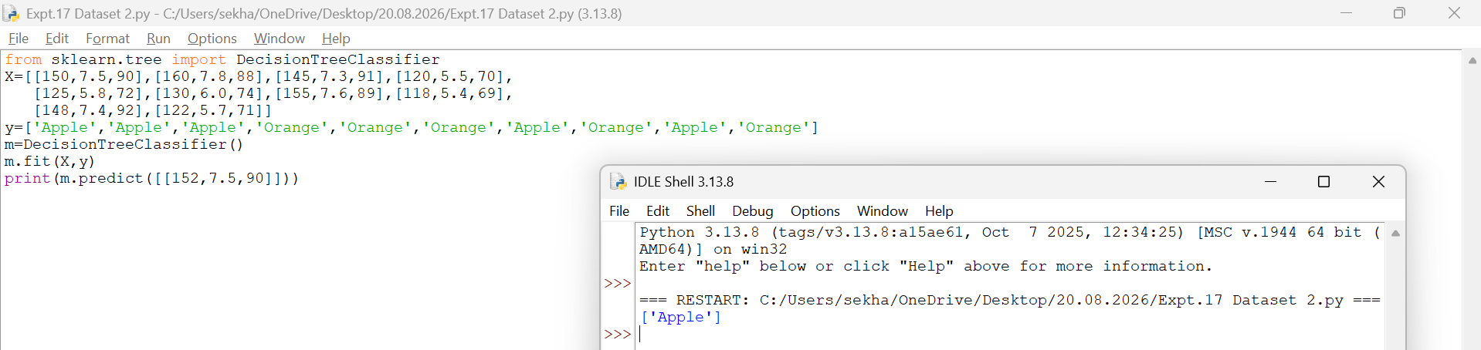
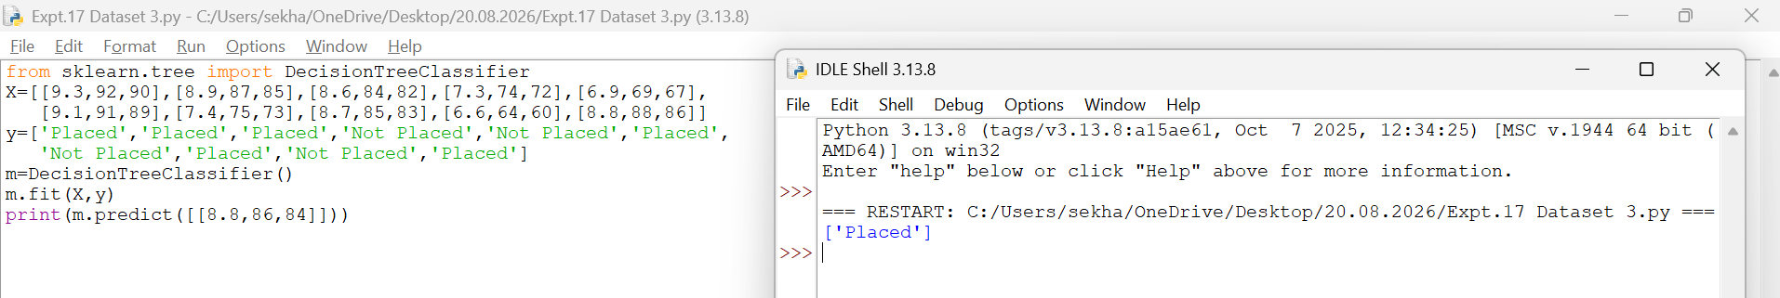
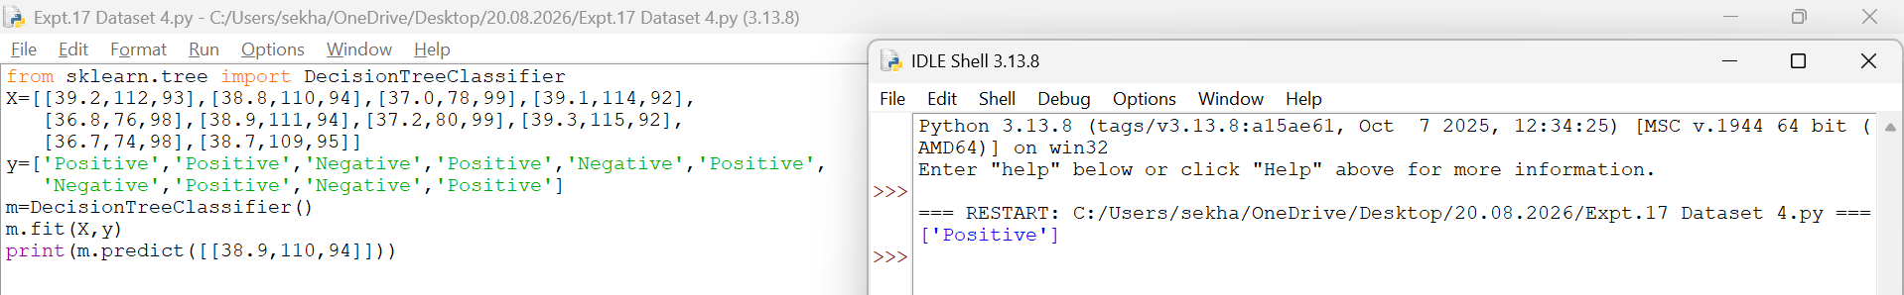
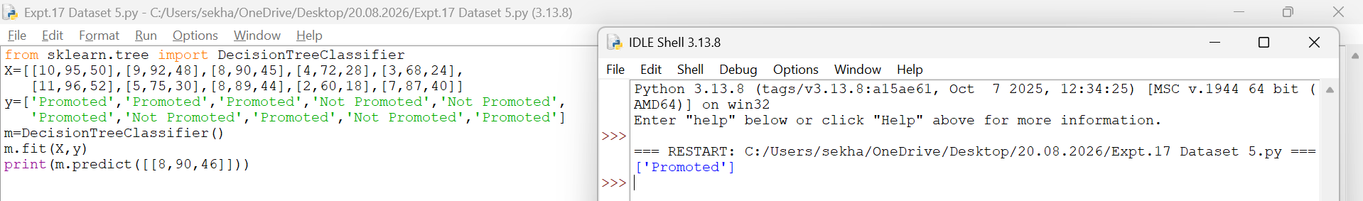
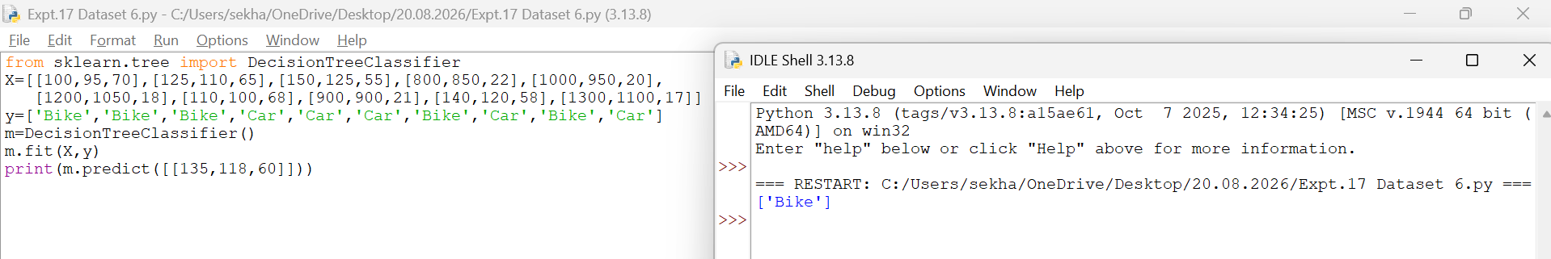
Result
Thus, the Linear Regression model was implemented successfully and the predicted mobile
price is 30000.

EXPERIMENT 18 – PERCEPTRON-BASED IRIS CLASSIFICATION
Aim
To classify Iris flowers using the Perceptron algorithm.
Procedure
1. Import the Iris dataset and Perceptron classifier.
2. Load the Iris dataset.
3. Train the Perceptron model using the training data.
4. Predict the flower class.
5. Display the predicted result.
Code and Output
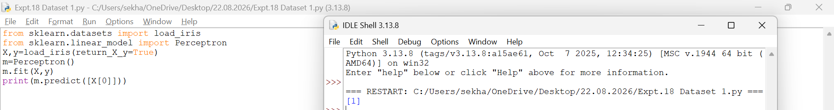
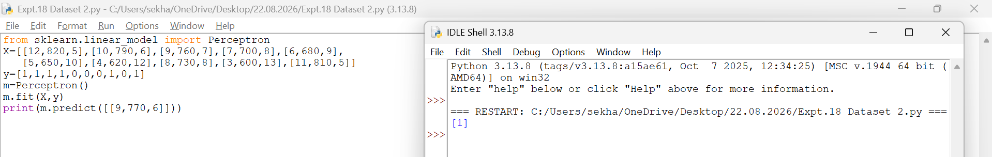
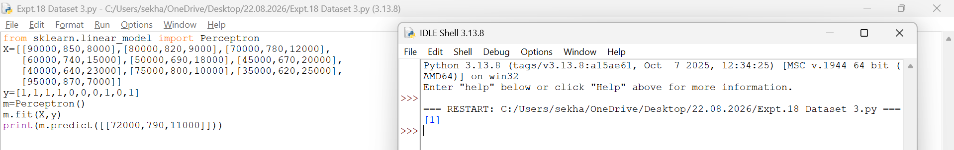
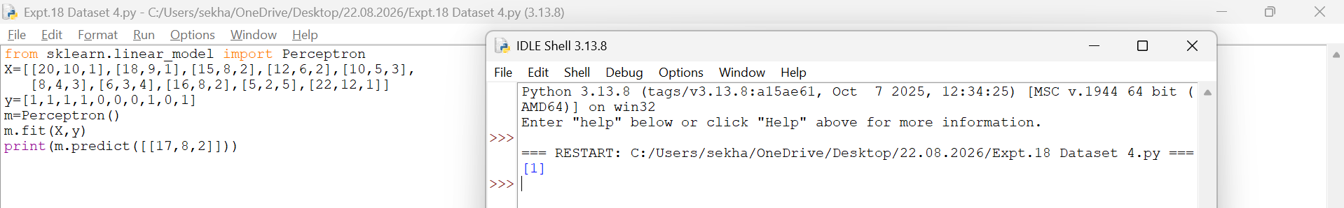
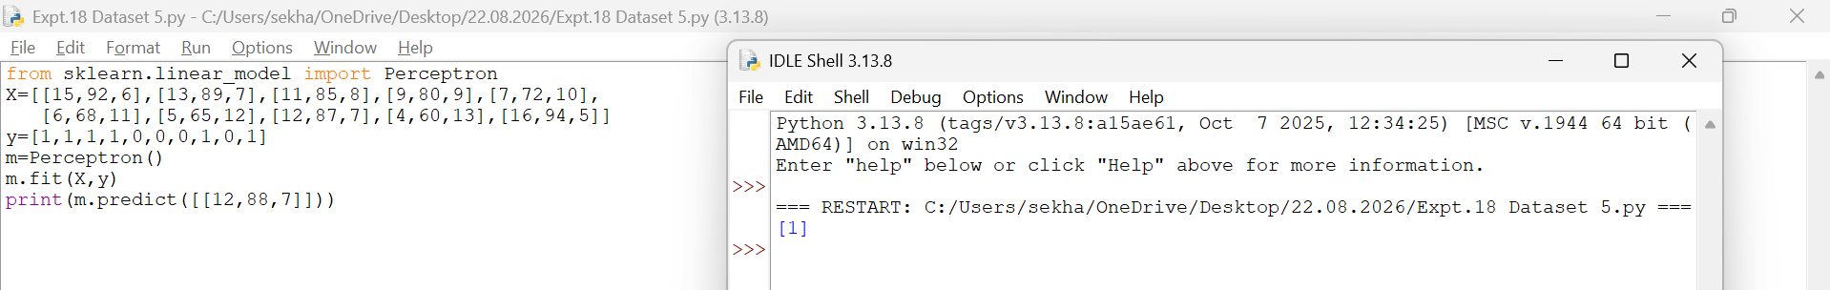
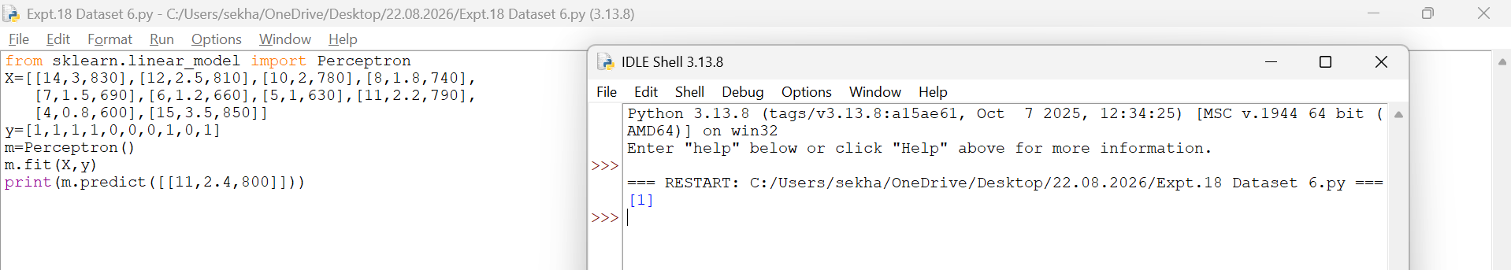
Result
Thus, the Iris flower was classified successfully using the Perceptron algorithm.

EXPERIMENT 19 – BANK LOAN PREDICTION USING NAÏVE BAYES
Aim
To predict bank loan approval using the Naïve Bayes algorithm.
Procedure
1. Import the GaussianNB classifier.
2. Create the dataset and class labels.
3. Train the model using the training data.
4. Predict the loan approval status.
5. Display the predicted result.
Code and Output
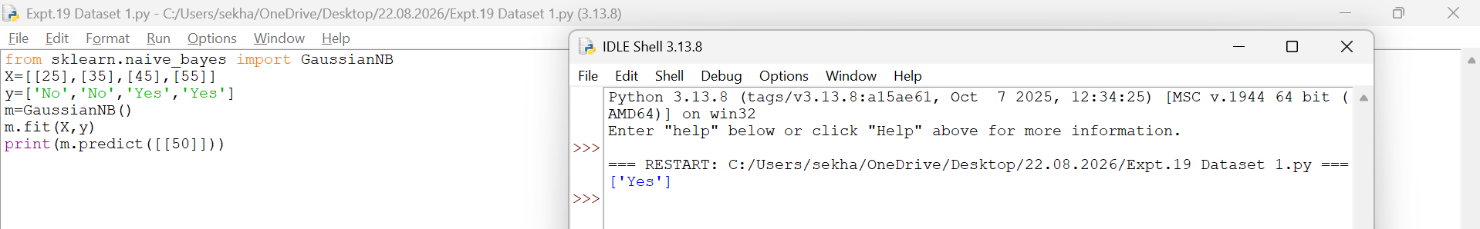
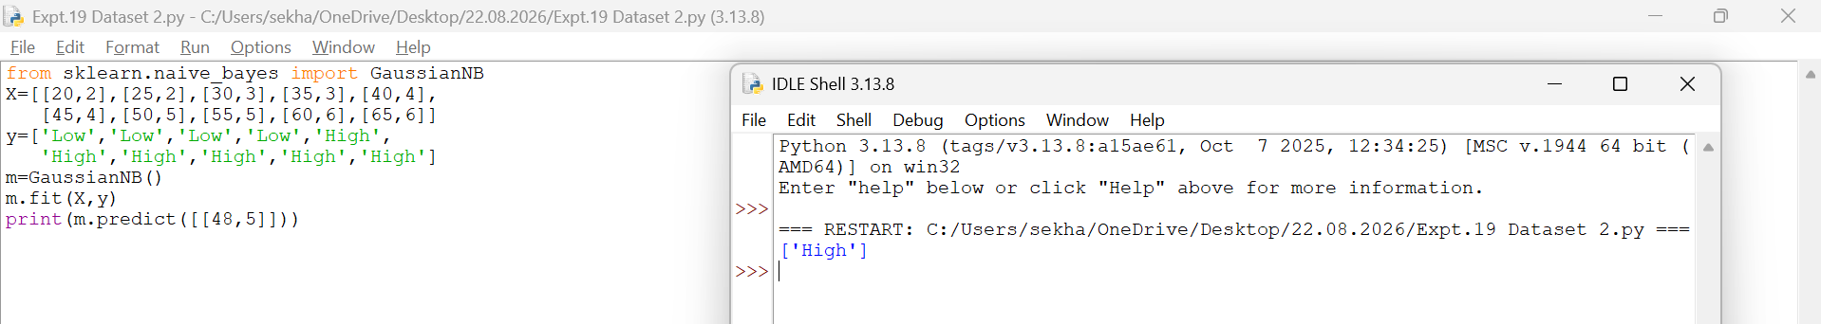
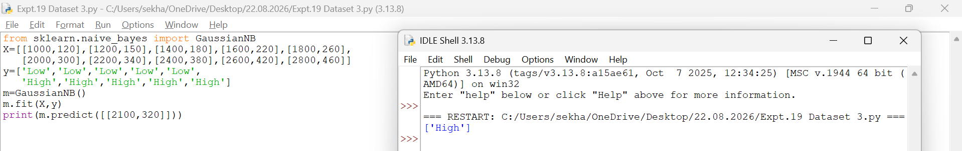
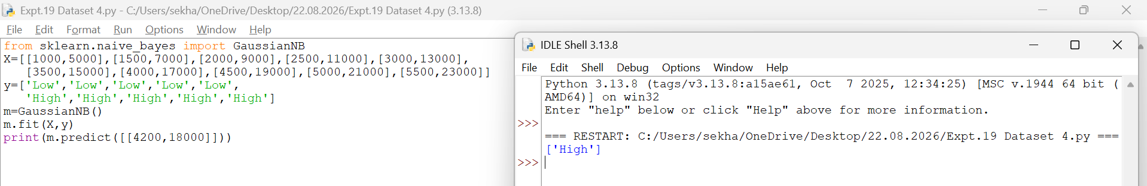
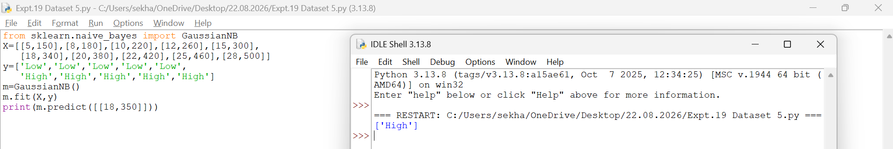
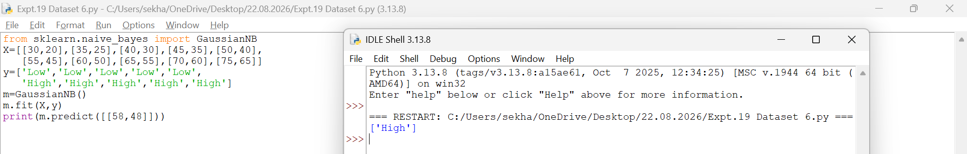
Result
Thus, the Naïve Bayes model was implemented successfully and the loan approval status was predicted as Yes.
EXPERIMENT 20 – FUTURE SALES PREDICTION
Aim
To predict future sales using the Linear Regression algorithm.
Procedure
1. Import the Linear Regression model.
2. Create the dataset and target values.
3. Train the model using the training data.
4. Predict future sales for a new input.
5. Display the predicted result.
Code and Output
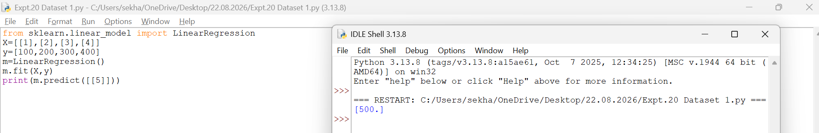
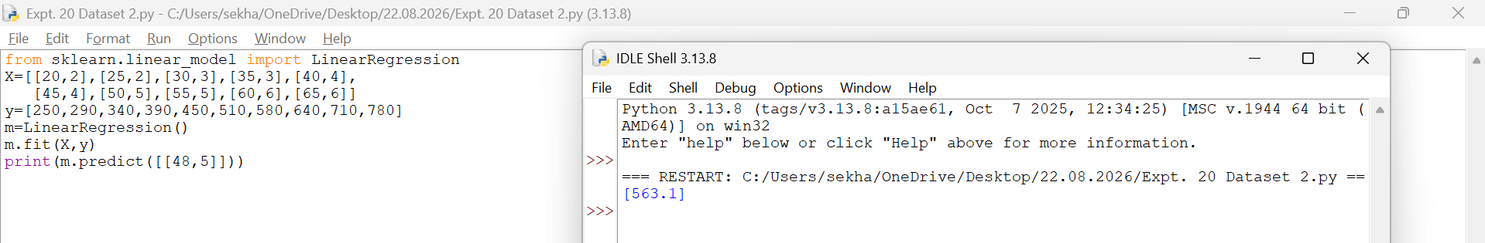
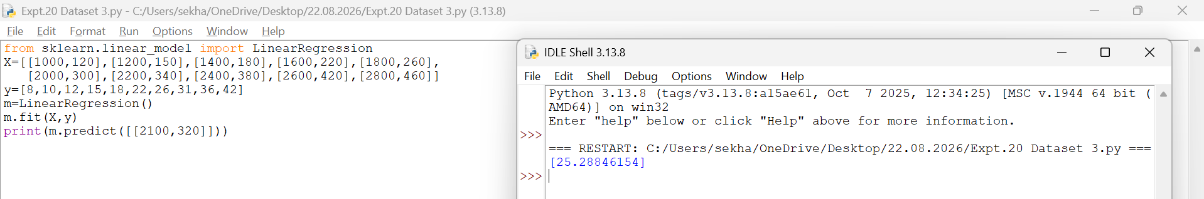
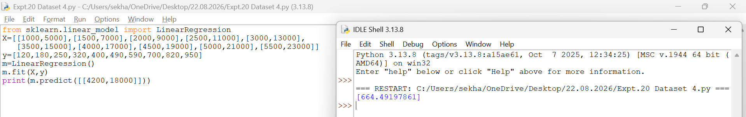
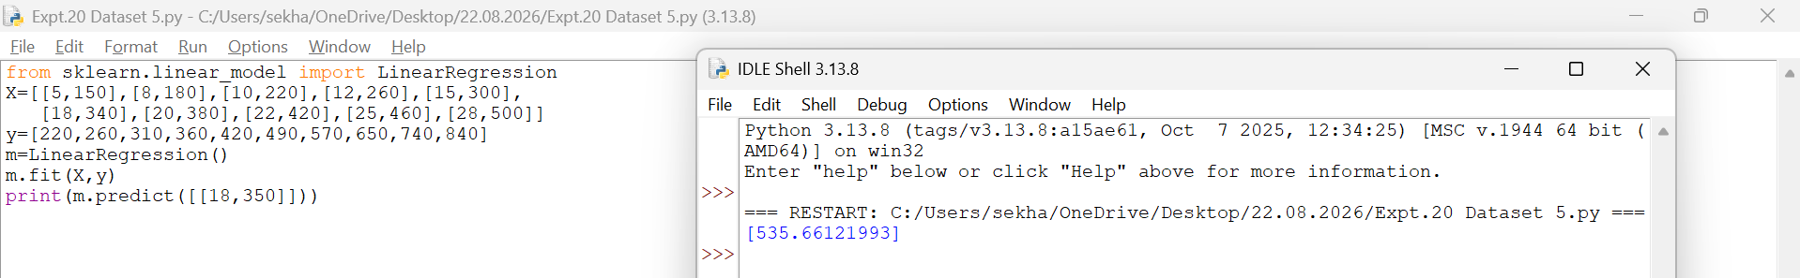
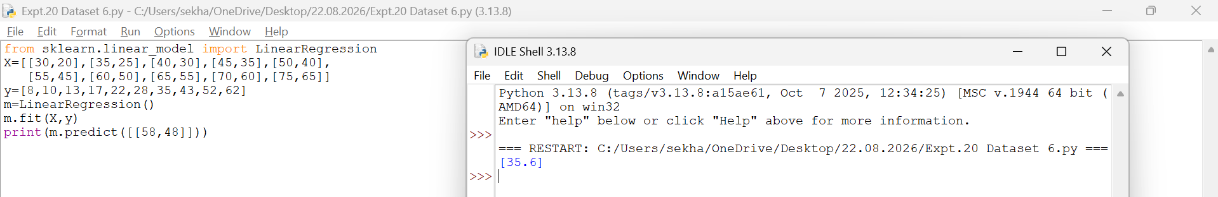
Result
Thus, the Linear Regression model was implemented successfully and the future sales value was predicted as 500.

